


Prepare and serve non-alcoholic beverages
D1.HBS.CL5.07
Trainee Manual




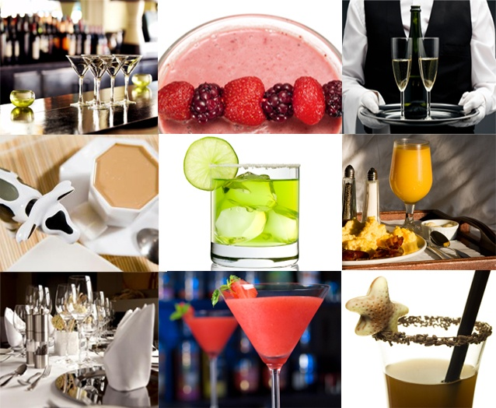

Prepare and serve non-alcoholic beverages

D1.HBS.CL5.07

Trainee Manual





Project Base
William Angliss Institute of TAFE
555 La Trobe Street
Melbourne 3000 Victoria
Telephone: | (03) 9606 2111
Facsimile: | (03) 9670 1330
Acknowledgements
Project Director: | Wayne Crosbie
Chief Writer: | Alan Hickman
Subject Writer: | Alan Hickman
Project Manager/Editor: | Alan Maguire
DTP/Production: | Daniel Chee, Mai Vu, Kaly Quach

The Association of Southeast Asian Nations (ASEAN) was established on 8 August 1967. The Member States of the Association are Brunei Darussalam, Cambodia, Indonesia, Lao PDR, Malaysia, Myanmar, Philippines, Singapore, Thailand and Viet Nam.
The ASEAN Secretariat is based in Jakarta, Indonesia.
General Information on ASEAN appears online at the ASEAN Website: www.asean.org.
All text is produced by William Angliss Institute of TAFE for the ASEAN Project on “Toolbox Development for Front Office, Food and Beverage Services and Food Production Divisions”.
This publication is supported by the Australian Government’s aid program through the ASEAN-Australia Development Cooperation Program Phase II (AADCP II).
Copyright: Association of Southeast Asian Nations (ASEAN) 2013.
All rights reserved.
Disclaimer
Every effort has been made to ensure that this publication is free from errors or omissions. However, you should conduct your own enquiries and seek professional advice before relying on any fact, statement or matter contained in this book. The ASEAN Secretariat and William Angliss Institute of TAFE are not responsible for any injury, loss or damage as a result of material included or omitted from this course. Information in this module is current at the time of publication. Time of publication is indicated in the date stamp at the bottom of each page.
Some images appearing in this resource have been purchased from stock photography suppliers Shutterstock and iStockphoto and other third party copyright owners and as such are non-transferable and non-exclusive. Clip arts, font images and illustrations used are from the Microsoft Office Clip Art and Media Library. Some images have been provided by and are the property of William Angliss Institute.
Additional images have been sourced from Flickr and SXC and are used under Creative Commons licence: http://creativecommons.org/licenses/by/2.0/deed.en

File name: TM_Prepare_serve_non_alcoholic_bev_refined





Table of contents
Introduction to trainee manual 1
Unit descriptor 3
Assessment matrix 5
Glossary 7
Element 1: Prepare and serve a range of teas and coffees 9
Element 2: Prepare and serve cold drinks 33
Element 3: Use, clean and maintain equipment and machinery for non-alcoholic drinks 55
Presentation of written work 69
Recommended reading 71
Trainee evaluation sheet 73
Trainee self-assessment checklist 75

Introduction to trainee manual

To the Trainee
Congratulations on joining this course. This Trainee Manual is one part of a ‘toolbox’ which is a resource provided to trainees, trainers and assessors to help you become competent in various areas of your work.
The ‘toolbox’ consists of three elements:
- A Trainee Manual for you to read and study at home or in class
- A Trainer Guide with Power Point slides to help your Trainer explain the content of the training material and provide class activities to help with practice
- An Assessment Manual which provides your Assessor with oral and written questions and other assessment tasks to establish whether or not you have achieved competency.
The first thing you may notice is that this training program and the information you find in the Trainee Manual seems different to the textbooks you have used previously. This is because the method of instruction and examination is different. The method used is called Competency based training (CBT) and Competency based assessment (CBA). CBT and CBA is the training and assessment system chosen by ASEAN (Association of South-East Asian Nations) to train people to work in the tourism and hospitality industry throughout all the ASEAN member states.
What is the CBT and CBA system and why has it been adopted by ASEAN?
CBT is a way of training that concentrates on what a worker can do or is required to do at work. The aim is of the training is to enable trainees to perform tasks and duties at a standard expected by employers. CBT seeks to develop the skills, knowledge and attitudes (or recognise the ones the trainee already possesses) to achieve the required competency standard. ASEAN has adopted the CBT/CBA training system as it is able to produce the type of worker that industry is looking for and this therefore increases trainees’ chances of obtaining employment.
CBA involves collecting evidence and making a judgement of the extent to which a worker can perform his/her duties at the required competency standard. Where a trainee can already demonstrate a degree of competency, either due to prior training or work experience, a process of ‘Recognition of Prior Learning’ (RPL) is available to trainees to recognise this. Please speak to your trainer about RPL if you think this applies to you.
What is a competency standard?
Competency standards are descriptions of the skills and knowledge required to perform a task or activity at the level of a required standard.
242 competency standards for the tourism and hospitality industries throughout the ASEAN region have been developed to cover all the knowledge, skills and attitudes required to work in the following occupational areas:
- Housekeeping
- Food Production
- Food and Beverage Service
- Front Office
- Travel Agencies
- Tour Operations.
All of these competency standards are available for you to look at. In fact you will find a summary of each one at the beginning of each Trainee Manual under the heading ‘Unit Descriptor’. The unit descriptor describes the content of the unit you will be studying in the Trainee Manual and provides a table of contents which are divided up into ‘Elements’ and ‘Performance Criteria”. An element is a description of one aspect of what has to be achieved in the workplace. The ‘Performance Criteria’ below each element details the level of performance that needs to be demonstrated to be declared competent.
There are other components of the competency standard:
- Unit Title: statement about what is to be done in the workplace
- Unit Number: unique number identifying the particular competency
- Nominal hours: number of classroom or practical hours usually needed to complete the competency. We call them ‘nominal’ hours because they can vary e.g. sometimes it will take an individual less time to complete a unit of competency because he/she has prior knowledge or work experience in that area.
The final heading you will see before you start reading the Trainee Manual is the ‘Assessment Matrix’. Competency based assessment requires trainees to be assessed in at least 2 – 3 different ways, one of which must be practical. This section outlines three ways assessment can be carried out and includes work projects, written questions and oral questions. The matrix is designed to show you which performance criteria will be assessed and how they will be assessed. Your trainer and/or assessor may also use other assessment methods including ‘Observation Checklist’ and ‘Third Party Statement’. An observation checklist is a way of recording how you perform at work and a third party statement is a statement by a supervisor or employer about the degree of competence they believe you have achieved. This can be based on observing your workplace performance, inspecting your work or gaining feedback from fellow workers.
Your trainer and/or assessor may use other methods to assess you such as:
- Journals
- Oral presentations
- Role plays
- Log books
- Group projects
- Practical demonstrations.
Remember your trainer is there to help you succeed and become competent. Please feel free to ask him or her for more explanation of what you have just read and of what is expected from you and best wishes for your future studies and future career in tourism and hospitality.

Unit descriptor
Prepare and serve non-alcoholic beverages
This unit deals with the skills and knowledge required to Prepare and serve non-alcoholic beverages in a range of settings within the hotel and travel industries workplace context.
Unit Code:
D1.HBS.CL5.07
Nominal Hours:
25 hours

Element 1: Prepare and serve a range of teas and coffees
Performance Criteria
1.1 Select ingredients, tea/coffee making equipment and crockery/glassware to prepare tea/coffee
1.2 Prepare drinks using appropriate method in accordance with customer requests and required timeframe
1.3 Evaluate drink before presenting to customer

Element 2: Prepare and serve cold drinks
Performance Criteria
2.1 Select ingredients, equipment and glassware
2.2 Prepare drink in accordance with standard recipes or to customer requests
2.3 Serve garnishes and accompaniments with drinks

Element 3: Use, clean and maintain equipment and machinery for non-alcoholic drinks
Performance Criteria
3.1 Use machinery and equipment safely in accordance with manufacturer's specifications and hygiene/safety requirements
3.2 Clean and maintain machinery and equipment regularly in accordance with manufacturer's specifications and enterprise cleaning and maintenance schedules
3.3 Identify problems promptly and report to the appropriate person

Assessment matrix
Showing mapping of Performance Criteria against Work Projects, Written Questions and Oral Questions
The Assessment Matrix indicates three of the most common assessment activities your Assessor may use to assess your understanding of the content of this manual and your performance - Work Projects, Written Questions and Oral Questions. It also indicates where you can find the subject content related to these assessment activities in the Trainee Manual (i.e. under which element or performance criteria). As explained in the Introduction, however, the assessors are free to choose which assessment activities are most suitable to best capture evidence of competency as they deem appropriate for individual students.
 |  |  | Work Projects | Written Questions | Oral Questions
Element 1: Prepare and serve a range of teas and coffees
1.1 | Select ingredients, tea/coffee making equipment and crockery/glassware to prepare tea/coffee |  | 1.1 | 1 – 6 | 1
1.2 | Prepare drinks using appropriate method in accordance with customer requests and required timeframe |  | 1.1 | 7 – 16 | 2
1.3 | Evaluate drink before presenting to customer |  | 1.1 | 17 | 3
Element 2: Prepare and serve cold drinks
2.1 |  | Select ingredients, equipment and glassware | 2.1 | 18 – 22 | 4
2.2 |  | Serve garnishes and accompaniments with drinks | 2.1 | 23 – 28 | 5
2.3 |  | Serve garnishes and accompaniments with drinks | 2.1 | 29 – 31 | 6
Element 3: Use, clean and maintain equipment and machinery for non-alcoholic drinks
3.1 | Use machinery and equipment safely in accordance with manufacturer's specifications and hygiene/safety requirements |  | 3.1 | 32, 33 | 7
3.2 | Clean and maintain machinery and equipment regularly in accordance with manufacturer's specifications and enterprise cleaning and maintenance schedules |  | 3.1 | 34, 35 | 8
3.3 | Identify problems promptly and report to the appropriate person |  | 3.2 | 36 | 9

Glossary
Term | Explanation
1 ounce/1 oz. | (liquid measurement) 30 millilitres/mls
AD | Anno Domini
Aerated waters | Sparkling soft drink – such as lemonade and cola
Arabica | Premium quality coffee bean
Brixing | Ratio of syrup to water in post-mix machines
Chai | Spiced tea
Cleaning schedule | List of when nominated items/areas must be cleaned
Creamer | Small jug (for milk/cream)
Decoration | Non-edible enhancement to a drink
Demi tasse | Half-cup: small cup used for Turkish and espresso coffee
Doily | Paper napkin placed under drink/on service plate or saucer
Flatware | Spoons
Food safety plan/programme | Protocols for maintaining hygiene and safety of food stuffs and food equipment, utensils and areas
Garnish | Edible items added to a drink to enhance presentation
Gomme syrup | Sugar syrup
House recipe | Standard recipe used by a property for making a drink
Infuser | Small metal ‘cage’ containing tea leaves immersed into boiling water to make tea (as opposed to placing leaves directly into the water)
Knock box | Bin into which pucks are ‘knocked’/emptied after espresso has been made
Maintenance schedule | Roster for maintaining nominated items/equipment
Mocktail | Non-alcoholic cocktail
PC | Portion controlled (packs/sachets)
Post-mix | Bulk soft drinks
Preventative maintenance | Maintenance undertaken at regular times with the intention the machine/equipment never breaks down
Puck | Used coffee grounds
RTD | Ready To Drink
Robusta | Lower quality coffee bean variety
Serviceware | Items required to serve teas or coffee
Shot | One serve of espresso (30 – 35 mls)
Single serve container | Take-away container intended to be used once and then discarded
Splits | Small bottles of soft drink
Sugar syrup | A liquid variation on granulated sugar used, for example, in cold beverages where customer wants to sweeten the drink
Swizzle stick | Drink stirrer
Temperature Danger Zone | 5˚C – 60˚C

Element 1:
Prepare and serve a range of teas and coffees

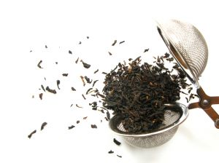
1.1 Select ingredients, tea/coffee making equipment and crockery/glassware to prepare tea/coffee

Introduction
The first step in preparing and serving teas and coffees is to select the necessary ingredient equipment and serviceware.
This Section identifies a range of items involved in this step.

Background to non-alcoholic beverages
The hospitality industry has undergone many changes over the years and one of the main changes is an increased emphasis on non-alcoholic drinks.
A truly rounded professional in the industry today will know as much about non-alcoholic beverages as they will about alcoholic ones, food and other aspects of the business.
Why has the demand for non-alcoholic drinks increased?
The role of non-alcoholic drinks has grown incredibly over recent years due to:
- The impact of drink-driving laws. More people are now aware they have a moral, social and legal responsibility not to drink alcohol and drive
- The increasing emphasis on ‘the family’ in many licensed premises. Many venues now target the entire family unit, and provide food, facilities and entertainment that will satisfy all age levels. It follows naturally that beverages must also cater for all ages
- A renewed interest in a healthy lifestyle. Some people have medical conditions which do not allow them to drink alcohol, and others simply want to remain as healthy as they can, believing the consumption of alcohol runs contrary to their efforts
- A general community feeling that overindulging in liquor is no longer as acceptable as it once was. Employers and work colleagues will not tolerate drunkenness in the workplace.
Many employers now have a ‘zero tolerance’ policy as far as alcohol is concerned.
There is no doubt employers also have a common law duty of care towards both customers and staff in relation to alcohol.

Basis for selecting ingredient, equipment and crockery/glassware
The basis for selecting items for making tea, coffee and/or cold drinks are:
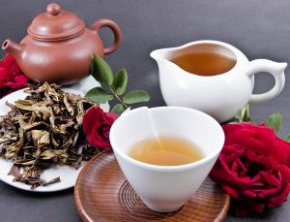
- Tradition
- House recipes
- Customer requests and preferences.
Tradition
There are traditional ways of making and serving many drinks.
For example, demi-tasse for short blacks, glasses for lattés and iced tea.
These traditional methods of making drinks and service protocols create customer expectations we must meet.
House recipes
House recipes are also known as ‘Standard recipes’.
They contain information and directions on how to prepare drinks setting out:
- Name of drink
- Ingredients to use
- Quantities
- Equipment and utensils required
- Procedure to follow
- Relevant details regarding the individual drink which may mention drink-specific information such as temperature/s and type of milk to use
- Service requirements including the crockery (or take away container) to be used, and garnishes, decorations and/or accompaniments required
- A photograph of the finished product.
Not all establishments use written house recipes.
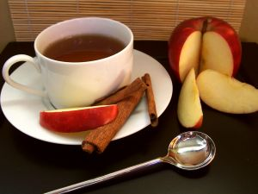
In many premises there will be a selection of books behind the counter to assist with making beverages. In other cases, it will be assumed staff will know what to do or will ask customers for help when making unique drinks.
Customer requests and preferences
Customer requests and preferences should be accommodated when making beverages, where possible.
There is no limit to the individual requests and preferences which may be made but they often relate to changes to ingredients, serviceware, temperature and garnishes and accompaniments.
In practice this can mean:
- Adding or removing an ingredient – no sugar, no ice, no milk, extra cream
- Adding more or less of an ingredient – extra syrup, double shot of coffee, just a splash of milk, really strong tea
- Using a different type and or size of cup, mug or glass – “served in a mug rather than a cup”
- Stipulating a service temperature – such as “Really cold, lots of ice”, “Warm but not hot”, “Boiling hot”
- Differences to garnishes and/or accompaniments – “extra mints”, “no lemon”, “no straw”.

Tea – general information
There are over 3,000 types of tea across the world.
Black tea
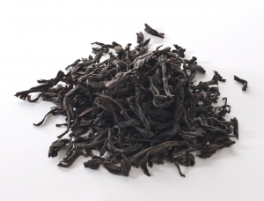
Black tea is referred to as ‘red (or ‘crimson’) tea’ by the Chinese because of its colour, and is the most popular tea in the world.
It comes from the fully oxidised leaves of the ‘tea plant’ called Camella Sinensis.
It is the tea commonly used for making iced tea and owes its popularity to tea bags where it made its debut to most of the world.
It is also popular with tea producers for blending with other ingredients (such as flowers, herbs, citrus, fruit) to produce an increasing range of tea-based drinks. Black tea is also mixed with other teas to make certain blended teas – see below.
Black tea is usually the strongest of all teas in terms of taste and contains the most caffeine.
It is available in tea bags and as loose leaf tea.
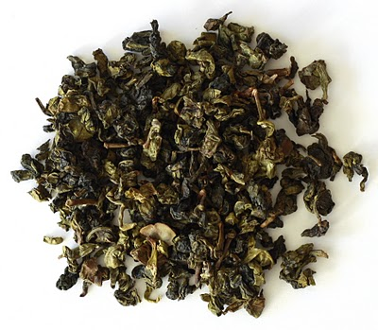
See video at http://video.about.com/coffeetea/Overview-of-Black-Tea.htm.
Semi-black tea
Known better in China as ‘Oolong’, semi-black teas are semi-oxidised leaves of the ‘tea plant’ called Camella Sinensis.
Semi-black tea requires a relatively longer infusion time than black tea, and many semi-black tea leaves can be re-used although this is more common in a home situation that in a commercial one.
Semi-black teas are also available in bags or in loose leaf form.
Blended teas
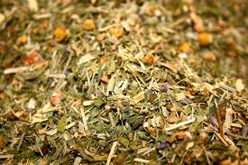
These teas result from mixing different teas together with a view to creating a consistent final product.
Teas blended together can come from different geographical regions or be different types of teas.
English Breakfast is the most popular blend – Irish Breakfast is also a blend.
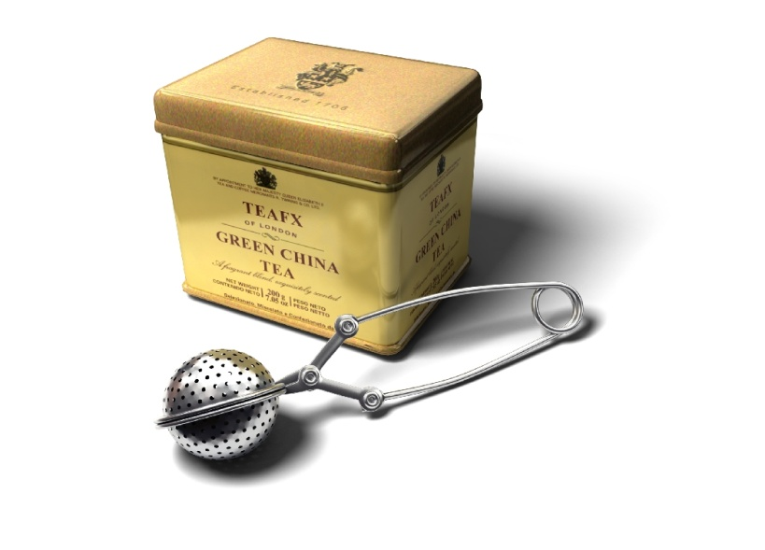
Green tea
Green tea is made from unfermented (hence, green) tea leaves and is very popular in Japan and China.
Green tea has recently been associated with having health benefits which are making it increasingly popular. Nearly all teas are enjoying a surge in popularity for health-related reasons.
Green tea has fairly popular versions known as ‘Gunpowder’ and ‘Rainflower’.
Scented teas
Scented teas are usually made by taking a black tea or a semi-black tea and adding ingredients to introduce a specific aroma and taste.
It is believed many of these teas originally evolved as manufacturers tried to mask the shortcomings of inferior quality teas, but today many of the scented teas are deliberate marketing ploys by producers seeking new niche markets for their products.
Ingredients added to the base tea may include herbs, flower blossoms or fruit peel.
Well-known scented teas include Earl Grey (which has oil from the bergamot citrus plant added to it) and Jasmine (jasmine flowers) but there has been a big growth in this area with scents also including apple, lychee, mango, strawberry, rose, lavender, mint and caramel.
Smoke is used to scent and flavour some teas, burning pine needles under the tea while the leaves are drying. Lapsong Souchong is a well-known tea made using a smoking process.
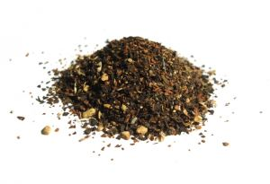
Chai tea
Chai is the word for ‘tea’ in some countries.
It is brewed with a variety of spices (such as ginger, cloves and pepper) which vary between different blends/recipes.
Visit the following website for more information:
- http://www.2basnob.com/chai-tea.html.
Websites for further information
There are numerous websites providing additional information regarding teas.
Try the following sites as a starting point and then follow links for more detailed information on teas:
- http://www.teavana.com/special-teas
- http://www.tenren.com/index.html
- http://coffeetea.about.com/od/typesoftea/Types_of_Tea.htm
- http://www.twinings.com.au/
- http://www.lipton.com.au/home/
- http://www.bushells.com.au/
- http://www.dilmah.com.au/.

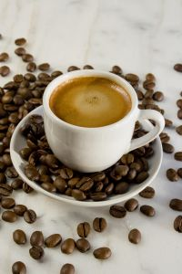
Coffee - general information
The history of coffee has been recorded from about 1000 AD onwards.
From about 1400 AD Europe began drinking coffee and its use exploded, with many innovations in its preparation and consumption being introduced.
In the world marketplace, coffee ranks alongside oil, steel and grain as an exportable raw material of the highest value. Coffee is the second most-traded commodity in the world. Indeed the economies of many of the prime coffee-producing countries are almost entirely dependent on the export of coffee for their natural wealth.
When there is a bad coffee crop, the price increases and the supply and quality of the coffee is reduced.
Origins
Coffee grows only in tropical regions. It is intolerant to frost and requires moderate rainfall, warm temperatures year-round and plenty of sunshine. The main coffee growing countries can be grouped into the following regions:
- Central America and the Caribbean – Mexico, Panama, Caribbean Islands
- South America – Brazil, Colombia, Ecuador, Peru
- Africa – Kenya, Tanzania, Cameroon
- Australia/Asia – India, Indonesia, Vietnam, New Guinea.
Robusta and Arabica
The two most widely used varieties of coffee beans are Robusta and Arabica.
Robusta beans grow in a wider variety of equatorial climates and deliver a bolder taste. The Robusta beans are rounder, smaller and have a straight seam.
Arabica beans are more sensitive to climate and altitude. They are considered of premium quality when compared to Robusta beans. Arabica beans are longer, more oval in shape and have an S-shaped seam.
Blending
The vast majority of roast and ground coffee, including all espresso coffees, are roasted coffee blends from various growing regions.
Blends include different percentages of Robusta and Arabica or may be 100% Arabica.
Each blend tastes different by virtue of the different flavours contributed from the different growing regions in much the same way the one wine grape variety from different growing regions will also taste noticeably different. It is a fact that each particular coffee growing region produces beans with a distinctive flavour.
Very, very few blends are made from 100% Robusta beans because of the level of astringency produced.
Some blends are called ‘origin blends’ meaning 100% of the coffee beans are sourced from the region named. This enables drinkers to purchase a coffee they know will have certain characteristics. For example, Costa Rican Arabica beans are famed for their fragrance, flavour and full body.
Coffee websites

There are many coffee-related websites.
You should visit coffee manufacturers’ websites sites such as:
- http://www.nestle.com.au/Default.htm
- http://grinderscoffee.com.au/
- http://www.lavazza.com.au/
- http://www.roberttimms.com/
- http://www.vittoriacoffee.com/index.php/1.html
- http://www.bushellscoffee.co.nz/.
Also visit the websites of:
- http://www.facebook.com/pages/Asean-Coffee-Federation/168413326607869
- http://www.gloriajeanscoffees.com.au/
- http://www.starbucks.com/
- http://www.acta.org.au/
- http://www.coffeereview.com/.

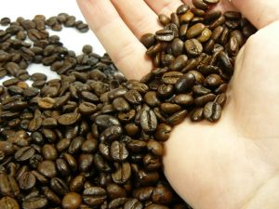
Selecting tea and coffee ingredients
The ingredients required will, as identified above, depend on the drink ordered by the customers and the house recipes for the property.
A representative list of ingredients includes:
- Coffee beans – premises offering espresso coffee will grind their own beans and may offer a variety of blends
- Sachets (PC packs) of ground coffee – for use in other coffee equipment such as plungers and dripolators
- Instant coffee, including decaffeinated. Despite the explosion in the use of espresso machines there still remains a role for instant coffee in nearly every venue.
Visit the following sites for product information and to gain an appreciation of what is available:
- http://www1.lavazza.com/corporate/au/index.html
- http://www.coffeebean.com.ph/
- http://www.nestle.com.au/Products/Featured-Brands/Nescafe
- Proprietary brands of flavoured coffee – check out http://www.javaberry.com/?module=429&action=viewCategory&idParent=12 for extra information
- Loose tea leaves – as appropriate for the types and styles of teas offered by the venue

- Tea bags – an option used in many venues for the provision of teas.
All types and styles of tea are available in the form of tea bags
- Sugar – bulk sugars including refined and raw as well as cubed and portion control (PC) packs. Sugar substitutes are now also mandatory inclusions when delivering non-alcoholic beverages.
See the following for examples:
- http://www.cw-usa.com/supplies-condiments-sweeteners-sugar-packets-case.html
- http://www.clubequal.com.au/
- Milk and cream – dairy products play a central role in offering white teas, coffees/espresso drinks. Make sure dairy products are fresh and not out of date
PC packs which combine coffee and milk, and coffee+milk+sweetner are also available and popular for use in guest rooms in accommodation facilities
- Syrups for coffees. Many venues offer flavoured coffees through the addition of syrups such as caramel, chocolate, white chocolate, Irish cream and hazelnut.
See the range available at http://www.alchemycordial.com.au/shop/coffee-syrups/12 and watch the two short videos
- Water – there will always be a need for a good supply of fresh water, iced water and boiling water
- Powders – some drinks may require chocolate powder, chocolate sprinkles, cinnamon, cocoa, nutmeg, chai spices and flavours and frappe mixes
- Lemons – for use with black tea.

Selecting tea and coffee equipment
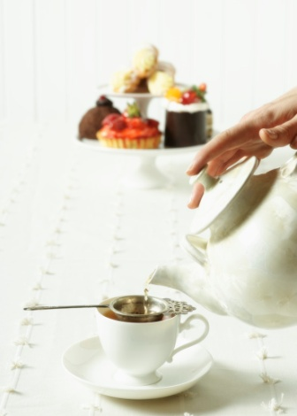
The equipment you will need to select will depend on the drinks ordered and the equipment available in the venue. For example, while espresso machines are common and popular, not every venue will have one.
Tea
Equipment for making tea may include (depending on the style and ambience of the property and the items on the menu):
- Hot water source – this may be a kettle, urn or a static supply (wall-mounted) unit
- Teapots – used for the service of tea and available in various sizes ranging from single serve (2-cup), through two-serve (4-cup) up to 12-cup.
Tea pots may be stainless steel or china.
May be used with an infuser.
See http://www.hospitalitywholesale.com.au/front-of-house/tea-and-coffee/tea-pots-and-infusers.html
- Hot water pots or jugs
- Infuser – a wide variety is available
- Strainers – for straining out tea leaves
See also http://coffeetea.about.com/od/teaandtisanebasics/a/EasyTeaEquipment.htm.
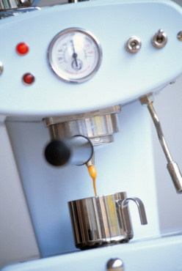
Coffee
Equipment required for the preparation of coffees can include:
- Coffee machines – often referred to as espresso machines.
See examples at:
- http://www.espressocompany.com.au/
- http://www.supremecoffeemachines.com.au/catalogue/commercial-coffee-machines
- http://www.fracino.com.au/
- http://www.espressoitalia.com.au/coffee/MACHINES/35+Commercial
- Coffee grinders – these may be provided as part of the main espresso machine or as a separate and stand-alone unit.
Most venues grind their beans several times a day. Some buy their coffee already ground meaning they will not need a grinder.
See sample grinders at http://www.santos.fr/40m.html
- Weighing equipment – electronic scales for checking the dosing of coffee dispensers
- Tampers – for tamping ground coffee into portafilters
- Thermometer – for taking the temperature of milk when heating it and texturing it for use in, for example, cappuccinos
- Bins – for discarded pucks, called a ‘knock box’.
- Urn or kettle – or some other hot/boiling water dispenser (other than the espresso machine).
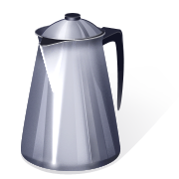
- Percolators, drip filters and plungers – for coffee service, other than espresso.
These may even be used by premises which have an espresso machine.
Many of the items used are domestic products used in a commercial setting and some are distinctly commercial in size.
See the following sites for examples:
- http://www.hostdirect.com.au/listProduct/Equipment/Urns+and+Percolators/
- http://www.vittoriacoffee.com/products-plunger.html.

Selecting crockery, cutlery and glassware
Tea and coffee can require the following:
- Crockery – the requirements can include china/porcelain or stainless steel items:
- Cups and saucers – variety of sizes in the range 60 mls (demi-tasse) through to 300 mls
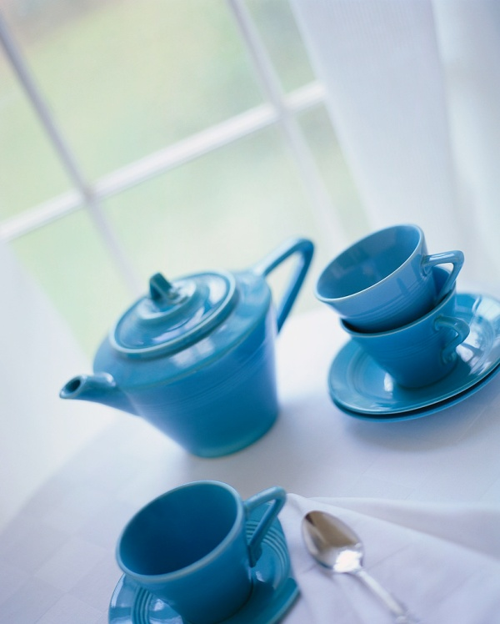
- Bowls – for sugar and accompaniments
- Mugs – for service of large hot and cold drinks: 300 mls plus
- Jugs – for milk, water and juices (150 mls upwards). A small jug may also be called a ‘creamer’
- Side plates – for placement or service of biscuits, mints or other items
- Tea bag holders – for holding used tea bags
- Silverware – for certain service requirements where a higher standard is needed.
Visit the following to view products available:
- http://www.cateringequipment.com.au/crockery/
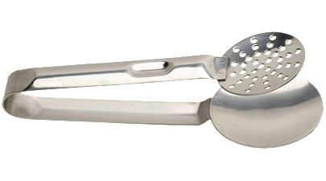
- Cutlery – you may require a variety of flatware items such as:
- Teaspoons
- Bar spoons/parfait spoons
- Coffee spoons
- Tea bag squeezers
- Glassware – a range of glasses to cater for iced tea and iced coffees as well as lattés.
Check out:
- http://www.crockerywares.com/
- http://www.hostdirect.com.au/.

1.2 Prepare drinks using appropriate method in accordance with customer requests and required timeframe

Introduction
It is important to prepare teas and coffees using the correct method for the drink ordered by the customer.

Basic service requirements
When making teas and coffees you should strive to:
- Follow house recipes unless the customer orders something different
- Provide what the customer wants. There may be a requirement to charge extra where the customer wants a beverage different to what is listed on the menu/drink list so beware of the potential for this
- Deliver a consistent product. The same drink should look and taste the same for all customers, today and tomorrow and every time it is made
- Minimise wastage. This can be achieved by not spilling drinks and through taking care to not over-produce drinks, causing the product to be thrown out
- Work quickly. An ongoing requirement is for all teas and coffees to be produced and served ‘as soon as possible’
- Deliver appropriate levels of customer service. When the order is taken and the drink is served.

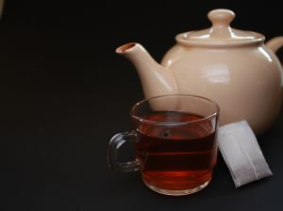
Making tea
Standard requirement
Two standard requirements apply:
- Always follow your house recipes or house rules when making tea if they differ from what is presented below
- Always factor in any special requests made by customers.
Tea is commonly made either:
- Using a pot with tea leaves. Some businesses use a teapot with tea bag while some premises place tea leaves into an infuser instead of placing tea leaves directly into the water in loose form
- Using a tea bag.

Making a pot of tea
A pot of tea is usually made using tea leaves.
Where a pot of tea is served guests normally serve themselves from the pot.
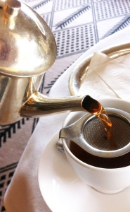
The standard practice is:
- Warm the tea pot by filling with hot water
- Prepare the tray in accordance with house standards to serve the tea which may mean:
- Getting the milk ready – pouring milk into a jug
- Getting the sugar ready – obtaining a bowl of white sugar, or sugar PC packs
- Preparing a jug or pot of boiling water which is used by guests to:
- Weaken the tea, if required
- Add to the pot to make more tea after they have served the first cup/s
- Preparing and setting out the cups and saucers and spoons and strainer (if infuser is not used)
- Cutting slices of lemon – for black tea
- Adding a tea leaf strainer to the tray
Preparing the tray is important so the tea can be served promptly once the boiling water has been added to the pot.
- Empty the water from the tea pot and discard the water
- Place the required amount of the selected tea into the pot or infuser. The amount of tea required will depend on:
- The size of the pot or the number of cups the pot will serve
- Customer preferences for strength of the tea
- House recipes.
A standard rule is one spoonful per person plus one for the pot.
- Add boiling water
- Serve immediately.
Note: in some cases sugar is not required in the service tray as the sugar will be a standard part of the table setting.

Making tea using tea bags
The use of tea bags is common for making tea.
A standard procedure is:
- Warm a hot water pot or jug by filling with hot water
- Prepare the service tray according to house standards with (as appropriate):
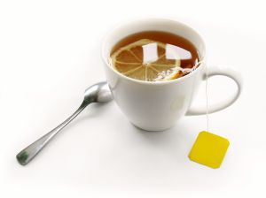
- Sugar
- Milk
- Lemon
- Hot water jug/pot
- Cups and saucers
- Tea spoons
- Tea bag strainer – a squeezer used to squeeze tea from the bag
- Rest for used tea bag
- Select the required tea type as identified by the guest
- Place the tea bag in the cup or on a side plate according to house standards
- Empty the water from the hot water pot/jug and discard the water
- Fill or refill the hot water jug or pot
- Serve immediately.
Note:
- The guest adds the water to the tea bag allowing them to make the tea to their individual preference. The water is not added to the cup and tea bag prior to or as part of service of tea using a tea bag
- In some cases sugar is not required in the service tray as the sugar will be a standard part of the table setting.

Making herbal tea
Tea bags are used for serving herbal tea in most commercial settings but a pot may also be used.
Standard procedure for service of herbal tea is:
- Warm a hot water pot or jug by filling with hot water
- Prepare tray for service according to house requirements and customer requirements. Note that common practice with herbal teas is:
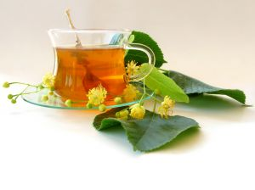
- Not to serve milk – unless requested
- Not to serve sugar – unless requested. Some venues may provide honey
- Place one cup and saucer for each customer. Many venues use a different style of cup and saucer for herbal teas often
- Add one tea bag per person either loaded into a cup or placed on side plate
- Add spoon and tea strainer or squeezer
- Empty the water from the hot water pot or jug and discard the water
- Fill or refill the hot water jug or pot
- Serve immediately.
Making iced tea
Where a standard recipe does not exist, a method is:
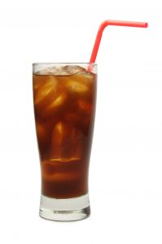
- Select the appropriate glassware – iced tea is traditionally served in a glass cup or mug as opposed to a teacup
- Make a quarter of a cup of strong tea using black tea
- Place tea in shaker full of ice
- Shake and strain into a glass full of fresh ice
- Garnish with a slice of lemon
- Sugar syrup served to customer if requested, in preference to serving granulated sugar.
Sugar syrup
Sugar syrup is also known as gomme syrup.
The recipe for sugar syrup can vary so find out what applies where you work. The following are two options.
- 500 mls of water and 500 gms of sugar – heat together in a pot, stirring to assist the dissolving of the sugar. Allow to reach the boil. Remove and allow cooling. Refrigerate, cover and store for later use
- Add boiling water (¹/₃ by volume) to sugar (²/₃ by volume) – stir to dissolve sugar. Allow to cool. Refrigerate, cover and store for later use.
Tea making videos
Watch the following to gain further insight into the making of teas:
- http://www.metacafe.com/watch/4620328/how_to_make_the_perfect_pot_of_tea/
- http://www.youtube.com/watch?v=OTrIwzRYRB0
- http://www.youtube.com/watch?v=1-8LbiVjmXc
- http://www.youtube.com/watch?v=v8y46pdaDMI
- http://www.youtube.com/watch?v=2ENUZxDx6SU.

Making coffee
Standard requirements
Always:
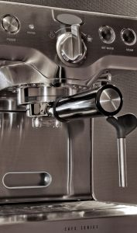
- Follow your house recipes or house rules when making tea if they differ from what is presented below
- Take into account any special requests made by customers.
Common coffee making methods
Coffee is commonly made:
- Using an espresso machine
- Using a plunger
- Using a dripolator.
Making espresso using espresso machine
The following steps are commonly applicable but can vary depending on the machine used.
Always:
- Read the instructions for the machine your are using
- Get an experienced person to demonstrate how to:
- Grind the coffee beans
- Use the machine
- Adjust the dosage
- Clean the machine.
It is important to master the process of producing a shot of espresso as this is the basis for many coffee-based drinks. See the recipes below:
1) Remove the group handle from the group head and knock out spent grounds from the previous coffee into knock box/tube.
Some coffee makers believe the spent coffee grounds should remain in the group filter basket locked in the group head until the next coffee is made in the belief the cake keeps the group at a consistent temperature and prevents metallic tastes from building up in the group head and handle.
Other coffee makers feel 10 minutes is the maximum time for spent coffee to remain locked in the group handle.
You need to know what applies in your workplace. Whatever option is followed, it is well recognised that a coffee machine in constant use produces the best coffee
2) Wipe out the basket with a cloth attached to the machine or to your apron and which is to be used for this purpose only.
Ground coffee sits better in a dry basket and clings to the sides.
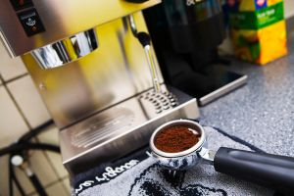
If the basket is rinsed and not dried, water under pressure will flow towards the water on the sides of the basket and not through the coffee, as it should and your coffee will be compromised. Also, rinsing may create a hazard of water on the floor and around the coffee machine
3) Place the group handle under the dispensing opening and dose one flick for a single shot and two for a double.
Make sure you use the correct group handle for the number of coffees you are making
4) Level the coffee by gently tapping on the sides of the basket.
The coffee will flow towards the point where you are tapping.
Once the coffee is level check enough coffee has been dispensed
5) Tamp the dosage
6) Wipe any coffee grounds off the top of the group handle
7) Before locking the group handle into the group run 30- 60 millilitres of water through the group head to flush out any coffee grounds and heat up the group head
8) Lock the group handle into the group head and press the button to start the extraction
9) The espresso should start to flow in around 5 seconds and it should take 25 – 30 seconds to extract a shot of 30 – 35 mls.
Espresso coffee terminology
Acidity
Acidity should not be confused with bitterness. 100% Arabica blends are characterised by a lively or fresh taste.
Acidity is picked up on the sides of the tongue when tasting coffee. Acidity decreases with darker roasting.
Back flush
Cleaning process using a blind filter and ‘flushing’ spent coffee grounds from the shower screen and around the rubber gasket in the group head.
Bitter
Bitter coffee is felt at the back of the tongue and is the result of badly brewed coffee.

Blind filter
A filter basket with no holes for cleaning the shower screen.
Body
Is the feel of the coffee in the mouth. Darker roasts have more body than lighter roasts.
Robusta has more body than Arabica and the ‘espresso’ method gives more body.
Crema
A well-made espresso should have this golden layer to about ½ centimetre on its surface. It is tiny bubbles of coffee oils and CO₂ trapped as the water is forced through the finely ground tightly packed coffee.
Crema can be used to diagnose a range of problems with coffee, grinder settings and the settings on the espresso machine.
Dose
This is the amount of ground coffee dispensed into the filter basket.
Should be 7 – 9 grams for a single shot and 14 – 18 grams for a double shot
Filter, basket or filter basket
This is a metal basket with tiny holes on the bottom which holds a specific dose of coffee. Filter baskets come in varying sizes.
7, 8 or 9 gm for the single filter holder or 14, 16 or 18 for the double.
Grind setting
Is the distance the grinding blades are apart to produce the required grind.
Grind setting can vary due to atmospheric conditions or blade wear.
Group handle
Also called filter holder or portafilter. Can be double-spouted or single spout.
It holds the filter basket and is inserted into the group head to make coffee
Group head
This is the part where the group handle is inserted. It contains the shower screen and a rubber gasket/seal.
Knock box or tube
A tube or a box where the spent grounds are knocked out into.
Rate of extraction
This is the rate at which the coffee flows from the group handle. The rate should be 30 – 35 mls in 25 to 30 seconds.
Correct rate of extraction depends on grind, dose and tamp.

Shower screen
This is a flat metal disk attached to the group head. The top side has fewer larger holes and the underside has many mesh sized holes – this disperses the pressurised water over the coffee in the filter basket.
Tamp
A tool used to compact and polish the coffee grounds in the group handle.
Can be attached to the grinder or be a metal tool – 15 kg of pressure is applied when tamping.
Espresso recipes
Espresso, shot or short black
A short (30 – 35 mls) intense coffee with a thick layer of caramel coloured crema on top results. Usually served in a small-preheated glass or espresso cup.
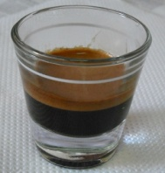
An espresso is the base of all drinks on the espresso menu.
Ristretto
In Italy this is the most popular drink on the espresso menu. It is usually called ‘un caffe’.
Only the first 15 mls is extracted from the coffee resulting in a very short, intense drink. The Italians refer to ristretto as ‘the poison of the coffee’.
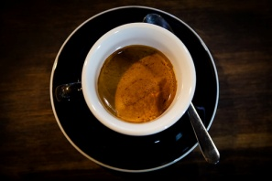
Doppio
A double shot served in the one glass or cup. This may be a doppio espresso (60 mls), or a doppio ristretto (30 mls).
A doppio espresso is used for longer drinks and a doppio ristretto is used as the base of any strong drinks.
Long black Americano or lungo
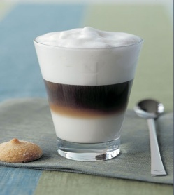
An espresso or a doppio espresso diluted with hot water from the boiler.
Macchiato
An espresso stained with a drop of cold or hot milk and served with a dollop of foam. Macchiato may be served short (an espresso) or long (a doppio and hot water in a glass).
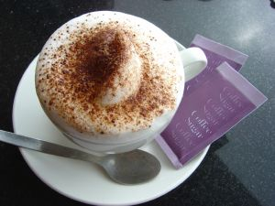
The long Macchiato is a Melbourne invention. Order macchiato in Italy and you will be served hot milk with a stain of coffee.
Cappuccino
Equal volume of espresso, hot milk and foam/milk crema.
Cappuccino is the ‘strongest’ milk drink as it is less diluted with milk.
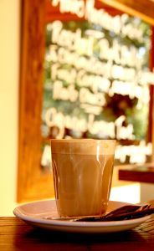
Latté
It is an espresso with hot milk and 1 centimetre of dense foam/milk crema on top.

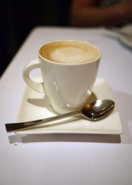
Flat white
Simply espresso and hot milk.
Mocha
Foamed chocolate milk is added to the espresso. Can be a mocha latté or a mochaccino.
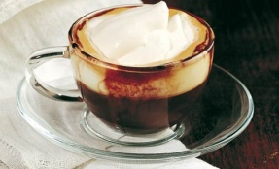
Vienna coffee
A long black topped with thickened cream.
Coretto
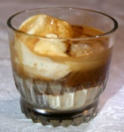
An espresso with a measure of flavoured liqueur or grappa.
Affogatto
Vanilla ice cream or gelato served with an espresso and can be served with a measure of flavoured liqueur
Flavoured coffee
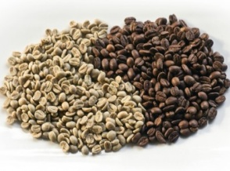
Flavoured sugar syrups have become a feature of many coffee outlets. Syrup is added to the espresso or foamed with the milk.
Decaffeinated coffee
This is coffee where the caffeine has been removed by a water soaking method or by neutralising the caffeine with chemicals at green bean stage.
Prepared the same way as other coffees but using decaffeinated coffee.
Using a plunger
Plunger coffee is popular as it combines good quality coffee with an attractive service method.
Subject to individual house protocols the following can be used to serve plunger coffee:
- Obtain correct size plunger. They are available in single, double and larger sizes
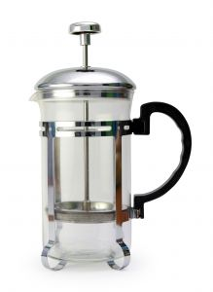
- Remove plunger and half-fill jug without water to warm the glass
- Prepare the service tray with sugar, milk or cream, cups, saucers, tea spoons, napkin, after dinner mint and/or other as required
- Discard hot water from glass jug
- Shake jug to remove excess water – do not dry with cloth
- Add required ground coffee according to house recipe and number of cups the plunger will hold
- Add boiling water over the coffee until the glass jug is nearly full
- Insert plunger into the jug, on top of the water and leave in this position until all the coffee granules have risen to the top (this could take two to three minutes)
- Press plunger down carefully and slowly to avoid spilling the coffee in order to filter the coffee and press all the granules against the base of the jug
- Plunger coffee is now ready to serve.

Using a dripolator
Filter coffee is made by using a dripolator.
Once the dripolator has been turned on and gas achieved the required heat, cold water is poured over the top element of the unit, and the water filters through the coffee and into an empty pot placed onto the lower warming plate.
Filter coffee is best served fresh – if it is allowed to sit for too long it ‘stews’ and becomes a very bitter tasting.
Although still popular in some restaurants, filter coffee is also served at functions, where it can be served by service staff or self-served by the guests.
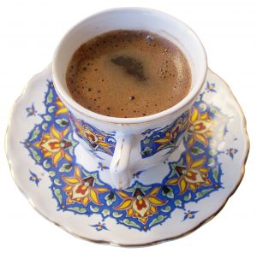
Turkish coffee
This is very strong, sweet, black coffee.
It is also known as Greek coffee.
Traditionally it is served in small cups and leaves a thick sediment in the bottom of the cup due to the very fine grind used on the beans. The grind is so fine this sediment cannot be filtered out.
Making iced coffee
Where a standard recipe does not exist, a possible method is:
- Select the appropriate glassware as determined by house recipe
- Fill ¹/₃ with cold espresso coffee
- Fill ²/₃ with cold milk
- Add ice cream and/or whipped cream
- Sprinkle with chocolate powder
- Serve immediately before cream and/or ice cream melts and starts running down side of glass.
Coffee making videos
View the following to learn more about coffee making:
- http://www.youtube.com/watch?v=rFOAW3aplPo
- http://www.youtube.com/watch?v=gc-sloCajV0
- http://www.youtube.com/watch?v=dDvpCyeKXS8.

1.3 Evaluate drink before presenting to customer

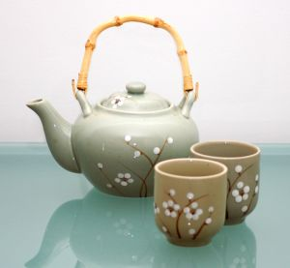
Introduction
It must be standard practice to check all teas and coffees before they are served to customers to optimise the service of the ‘perfect’ cup of tea or coffee.
It is important to understand ‘eye appeal’ is ‘buy appeal’.
Customers will see their drink before they taste it and they will start forming opinions about what it will taste like based on what it (or its presentation) looks like.

Checking the serviceware
You need to visually inspect all items to make sure:
- All serviceware is clean and not cracked or chipped
- The correct items have been provided to match the drink
- Sufficient quantity of items have been supplied to cater for the number of beverages to be served
- Layout of items on service trays is uniform and conforms to house standards.

Checking the accompaniments
You need to ensure:
- All advertised items have been provided as indicated:
- On the menus/drink lists
- By house recipes
- Special requests made by customers have been provided
- Accompaniments have been located or positioned uniformly and conform to house standards.

Checks for every drink made
There is a need for you to use your senses of sight, smell and touch to check and evaluate every drink you make.
In practice this means:
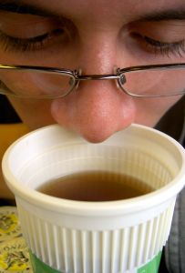
- Looking at the finished product to make sure it looks acceptable. Things to check are:
- All products of the same type, look the same:
- Filled to same level
- Dusted as appropriate
- In the same style glass/cup/mug
- With the required topping (cream, sprinkles, marshmallows)
- The correct number of drinks have been served to match the order placed
- Milk and cream used has nor exceeded its ‘Use By’ date
- Sufficient cups and saucers are provided for the number of people who are partaking in a pot of tea or coffee
- The product in the glass or cup looks as it should look, that is:
- Nothing floating in solution which should not be there
- No ingredients used which should not have been used
- Specific customer requests have been accommodated in relation to:
- Strength
- Size of cup/glass
- Additions
- Reductions
- There are no spills into the saucer or drips running down the side of a cup or mug or glass. If service of drink results in the drink being spilled into a saucer, or onto a napkin placed under a drink, then you should replace the saucer and/or napkin. In some cases it may be necessary to make the drink again.
- Using your sense of smell to detect if there are any ‘off’ smells from things such as, for example, sour milk or cream which are out of date, or brewed coffee which has become stewed and/or burnt
- Using your sense of touch to ensure:
- Hot drinks are served hot
- Cold drinks are served cold.
A key to ensuring this occurs is to ensure items are served immediately they have been made.

Work Projects
It is a requirement of this Unit that you complete Work Projects as advised by your Trainer. You must submit documentation, suitable evidence or other relevant proof of completion of the project to your Trainer by the agreed date.
  - Demonstrate or provide other evidence you have selected the ingredients, equipment and correct crockery/glassware and/or other serviceware to:
- Prepare and serve a pot of tea
- Prepare and serve a cup of tea using a tea bag
- Prepare and serve an iced tea
- Prepare and serve flat white coffee
- Prepare and serve two espresso coffee variations of your choice.

Summary

Prepare and serve a range of teas and coffees
When preparing and serving a range of teas and coffees:
Follow house recipes and/or tradition
Accommodate customer special requests and preferences
Select ingredients to match the needs of the order
Select serviceware size and quantity to meet requirements of the order
Ensure dairy products are fresh
Learn how to serve tea using a tea pot and using tea bags
Get to know the various coffee recipes which are based on the basic espresso
Learn the terms associated with coffee so you can talk professionally about coffee
Strive for consistency when preparing and serving items
Learn how to make hot and cold tea and coffee drinks
Learn different methods for preparing coffee
Evaluate all teas and coffees before serving them.

Element 2:
Prepare and serve cold drinks

2.1 Select ingredients, equipment and glassware

Introduction
The starting point for preparing and serving cold drinks is to ensure the correct ingredients, equipment and glassware is selected for each individual drink.

Factors determining the ingredients, equipment and glassware to be used

The selection of ingredients, equipment and glassware for the preparation and service of cold drinks will be dictated and influenced by:
- Customer requests and preferences which you should always try to accommodate
- Items offered on the menu/drinks list. Most cold drinks prepared for customers are taken from this list and the necessary ingredients and other items for preparing these beverages are usually available at the workstation
- House recipes – see previous section
- What is available in the venue. All venues have limitations in terms of what they have available.

Selecting ingredients
Ingredients required for preparing and serving drinks will include the following basic categories, all of which will be discussed in more detail in this section:
- Fruit juices – all types including fresh squeezed and commercially prepared. For ones that are ‘bought in’ you need to verify they are fresh or, if it exists, within the ‘Use By’ date
- Fruit and vegetables for producing fruit juices, vegetable juices and garnishes. Check products are fresh and suitable for use
- Dairy products such as milk, cream and yoghurt. Check items are within their ‘Use By’ date
- Aerated waters – ‘soft drink’ also known as ‘carbonated beverages’
- Ice cream for use in milkshakes, thick shakes and iced coffee. This may be traditional ice cream or specialist soft-serve product
- Powders – chocolate, malt
- Water/s – still, sparkling and flavoured
- Cordials to add to other beverages for colour and flavour
- Ice – block and crushed.
Points to note
When selecting and assembling ingredients for non-alcoholic drinks, points to consider are:
Refer to the advertised drinks list
The list of non-alcoholic drinks the venue offers must be seen as the starting point for selecting and assembling ingredients and equipment.
Experience will quickly teach you which items are the most popular and more effort needs to be spent ensuring materials are ready for those popular items.
In some properties a checklist is used to guide staff through their preparation activities to make sure all necessary requirements are in place and in sufficient quantities.
Where you become aware that a vital ingredient or item of equipment is missing or not working properly, this must be notified to the supervisor immediately and other staff must be advised if this means certain drinks advertised by the venue are unable to be served.
Note any stated or known customer preferences
Some customers prefer their drink customised to an extent and you should be happy to do this.
Use common sense about meeting the variations requested and ask management where you think an additional charge should be made for extra ingredients.
The addition of extra flavouring or syrup, extra fruit, more ice cream or the use of a larger glass or take away drink container will normally incur extra charges.
Use appropriate ingredients
In many circumstances the preparation of non-alcoholic drinks can enable you to use raw materials unfit for use anywhere else. This is not to say there is anything wrong with these products other than that they simply look unacceptable.
Fruit is a common example; it can look unappetising if presented as an item of fruit on a platter but it is perfectly suitable for blending, or juicing.
Note fruits and vegetables used on displays must look appealing, attractive and appetising.
Prepare enough ingredients for all the orders you have
If, for example, you have an order for two smoothies of the same type then make both at the same time in the one blender.
Do not make one in one blender and one in another.
By making both drinks at the same time, you achieve consistency of the finished product in terms of eye appeal, taste, texture, colour and temperature.

Selecting equipment and utensils
Commonly used equipment and utensils for making cold non-alcoholic drinks include:
- Juicers – commercial and domestic versions are used. Commercial ones have a larger capacity and more powerful motor
- Milkshake machines – for mixing milkshakes and thick shakes
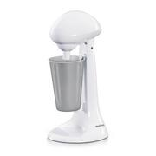
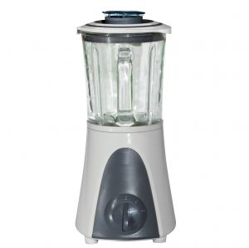
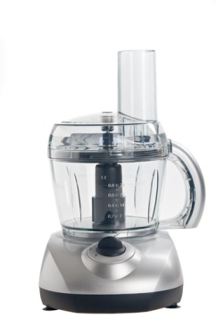
- Soft serve ice cream dispensers
- Blenders – used for making smoothies, frappes and other drinks
- Post-mix systems – a bulk soft drink dispensing system
- Ice crusher
- Bottle openers
- Knives and chopping boards
- Ice containers
- Tongs and scoops – for handling ice and fruit pieces.
Points to note
Ensure that all equipment and machinery used is clean
This means, especially where it is on public display, all equipment used in the drink production process looks clean, and is clean inside.
This is particularly an issue where there is limited equipment and each item can be expected to experience high usage.
Ensure all equipment you use is well cleaned immediately after you use it
This may be easier said than done, but it is important. For example, if you leave the blender uncleaned, then someone else may pour ingredients into it before realising it hasn’t been cleaned.
This means those ingredients will have to be thrown out. If they are used, then the customer will receive a tainted drink, and may complain, or not return.
Follow the requirements of your Food Safety Plan when cleaning these items. Generally speaking equipment will need to be cleaned and sanitised after every use or in between uses, and the sooner they are cleaned after use the easier they will be to clean.

Selecting glassware and other serviceware
In relation to serving drinks items may include:
- Glasses such as:
- Old fashioned glasses
- Highball glasses
- Pilsener glasses
- Mugs
- Milkshake glasses
- Soda glasses
- Cocktail glasses for non-alcoholic cocktails
- Jugs in a range of sizes for fruit juice and gomme syrup
- Metal milkshake containers
- Take-away drink containers with lids known as single serve items
- Drinking straws.

Need to know house policies
You must find your workplace requirements in relation to the following:
Surplus product
When making a drink during a service session you need to know the house policy on wastage and overages. What is the house policy if you make too much of a product?
Do you give it to the customer as a bit of a bonus?
Or is the policy to throw it out?
Are you allowed to drink it?
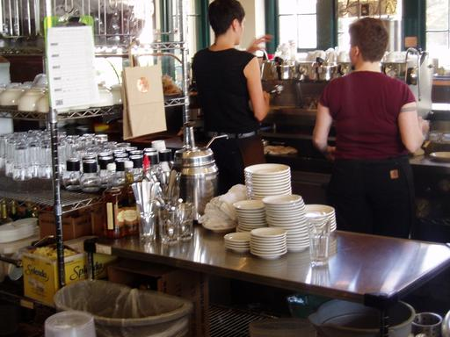
Layout of ingredients and equipment
Most properties will have a standard, pre-set layout for all their equipment and ingredients.
This facilitates stock taking, reordering and provides a consistent location for items to optimise working efficiency.
You will be expected to comply with the existing layout requirements.
Refraining from eating or drinking the products
When dealing with non-alcoholic beverages some staff believe it does not matter if they eat a piece of fruit, or drink a milkshake. Since alcohol is not involved they do not see a problem with this.
Most venues however will prohibit staff from eating or drinking while on duty. It looks bad for members of the public to see staff eating and drinking while at work and the product consumed by staff represents a loss to the business as it is not paid for.
Check with management to see what applies where you work because there is quite a variation in the attitudes and policies in this regard.
Some venues will allow you to eat or drink almost anything while others will stipulate a restricted range of nominated items you can eat or drink free of charge, and some will prohibit staff from eating or drinking anything when on duty.
Most employers will require you to eat or drink out of public view.
Discarded stock
Some properties have requirements relating to discarded stock.
Where stock has to be thrown out because it has ‘gone off’ or exceeded its use-by date there may be a need for you to complete a form identifying:
- What was discarded
- How much was discarded
- How it was discarded
- Why there was a need to discard it.

Need for product knowledge
Product knowledge is a vital aspect of your professionalism and it is no different when dealing with non-alcoholic beverages.
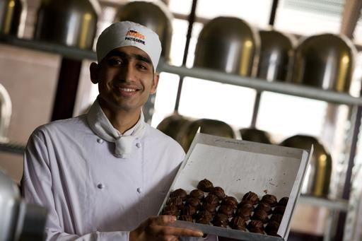
You must cultivate your knowledge of non-alcoholic drinks so you can:
- Describe and suggestively sell non-alcoholic drinks to customers
- Recognise a non-alcoholic beverage from a description given to you by a customer who is not sure about what they want to order.

Range of possible non-alcoholic drinks
Non-alcoholic beverages include both hot and cold drinks, and are nearly always available for on the premises consumption as well as in take away form.
Examples (in addition to iced tea and iced coffee mentioned in the previous Element) include:
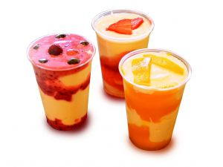
- Milkshakes
- Flavoured milks
- Smoothies
- Hot or iced chocolate
- Juices, and freshly squeezed juices
- Cordials and syrups
- Waters
- Soft drinks. These are also known as aerated waters; either bulk ‘post mix’ products or products from bottles or cans
- Non-alcoholic cocktails known as ‘mocktails’
- Frappés.

Milkshakes
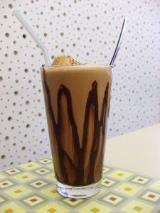
These are traditional favourites and extremely popular despite other alternative milk-based drinks available.
The basic milkshake is a blend of cold milk, ice cream and a flavouring agent (cordial or essence). Malt is a common option.
Customers may ask for extra ice cream, extra flavour or double malt.
There is a range of flavours and preparation and service varies marginally in some aspects, and widely in others.
Interesting details and history about milkshakes can be found at:
- http://en.wikipedia.org/wiki/Milkshake.
A variation on the milkshake is a thick shake which is basically the same as a milkshake but with more ice cream.
Venues with soft serve ice cream machines generally use soft serve to make their thick shakes.
Flavoured milk
A variation on the traditional milkshake is the simpler ‘flavoured milk’ (milk with added flavouring) sometimes stirred by the milkshake machine, sometimes not.
In some premises, the proprietary brands of RTD flavoured milk are also available for service.
Flavoured milks are normally served chilled, but some (‘egg nog’ and ‘chocolate’) are also delicious when heated (using microwave or espresso machine steam wand).

Smoothies
A healthy drink combining milk and fruit, blended with ice in a blender until ‘smooth’.

Chocolate drinks
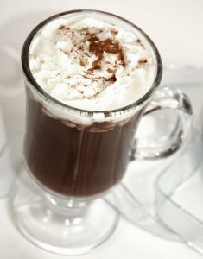
Hot chocolate
This is powdered drinking chocolate with hot milk – sugar is optional.
Served in a big mug perhaps with a marshmallow.
Iced chocolate
This is powdered drinking chocolate with icy cold milk, vanilla ice cream and sometimes cream.
Dust with powdered drinking chocolate, served in a parfait glass with a parfait spoon.

Juices
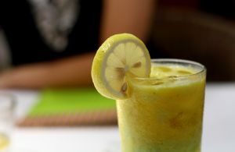
Many types of fruit can be turned into juices and Juice Bars have made these a popular drink type.
Some establishments only use proprietary brand fruit juices bought in and they offer only the traditional tomato juice, orange juice, pineapple juice and perhaps, apple juice.
Venues serving breakfasts usually boast more juices than other premises.
Bought-in product may come in PCs or in larger containers (tins or plastic containers), ranging from 1 litre to 10 litres which are decanted into jugs, which in turn are used to fill glasses.
Other venues boast a domestic or commercial juicer and make their own juices. There are many single fresh juices that can be made, plus lots more combinations of two, three or more different juices.
Making vegetable juices is an option too.

Cordials and syrups
Cordials are mixed with water, soda water, or lemonade to create a flavoured drink.
The amount of cordial used will depend on customer taste and the quality (which really means intensity of flavour) of the product.
Common cordials are lime juice, sarsaparilla, cloves, raspberry, peppermint and grenadine (a bright red, pomegranate flavour).
Syrups can be one of two types; for mixing with water or for mixing with milk. Syrups/cordials for soft drink cannot be used for milk drinks and vice versa.
Used as the base for post-mix, syrup is mixed with chilled water to produce the finished ‘aerated water’ product.
Syrups can be used to flavour milkshakes and flavoured milk.
When discussing non-alcoholic drinks, it is a good idea to make sure you know which one is being talked about; a caramel milkshake sounds good but a ‘blue heaven’ aerated water would not be.
Flavouring syrups for milkshakes
There are many different flavours available but traditional ones include Chocolate, Strawberry, Caramel, Lime, Banana, Vanilla, Coffee, Blue Heaven, Spearmint.
Check out the 150 different flavours at http://www.shakeking.com/.

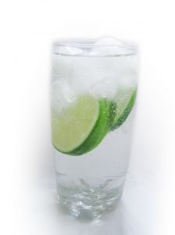
Waters
Water has become an amazingly ‘trendy’ drink. It can cost more than an alcoholic drink, and now comes in a wide range of choices.
Most waters are served neat, with a slice or wedge of lemon; ice is offered.
Small ‘split’ bottles are common – one split per serve, presented unopened to guarantee the contents are genuine. The cap can be removed in front of customer.
The majority of waters are ‘plain’. Options include spring water, mineral water, spa water, local or imported, still or sparkling.
Some waters offer added fruit juice – around 5% fruit juice – in a variety of flavours including lemon, pineapple, and orange.

Soft drink
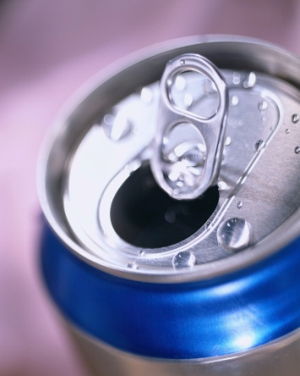
Soft drink, also known as 'aerated waters', includes cola, lemon squash, lemonade, bitter lemon, soda water, dry ginger and tonic water.
Post-mix is a popular delivery system. It is quick (there are no empties to get rid of, and you aren’t always opening bottles or cans and forever running out) but some outlets will insist on using the traditional bottles and cans.
Many customers prefer the packaged option but post-mix is more popular with management: the profit from post-mix is much higher than from the packaged alternative.
It is always wise to have some packaged soft drink stowed away somewhere for use in an emergency, perhaps when the power goes off, or the post-mix stops working.
Generally speaking, though, the packaged units are only kept for sale as takeaways.
Brixing
Where a post-mix system is used to serve soft drink, there should be a program in place to check the quality of the final product.
This includes checking the product temperature, and checking (and adjusting where necessary) the ‘brixing’.
With use, the ratio of syrup to water can alter, resulting in the drink not tasting as it should.
Each head (the unit where syrup and water are mixed together at the point of service) is able to be individually adjusted, which means you can increase or decrease the mix of both water and syrup.
Suppliers of the syrup will inform you of the correct brixing for each product line, and the equipment manufacturer or supplier will show you how to check and adjust the brixing.
Incorrect brixing is the biggest criticism of post-mix drinks. Many customers will say the product tastes weak, or is not as it should be.
The post-mix also needs to have its carbonation level checked to ensure its effervescence is correct.

Non-alcoholic cocktails
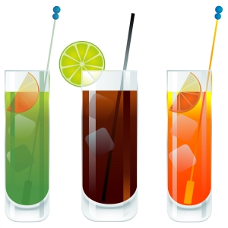
Mocktails are non-alcoholic cocktails. The base is usually carbonated soft drink or a fruit juice.
You can add fresh fruit wedges, sugar, honey, milk, yoghurt, sugar syrup, concentrate pulp, just to name a few suitable ingredients.
Mocktails usually require blending because they often have chunks of fruit in them needing to be liquefied. They are usually served in a cocktail glass and garnished with the type of fruit best matching the base.
Your establishment may have a special Mocktail List. You can invent your own mocktail, ensure it is tasty, looks inviting and of course, contains no alcohol.
Websites
The following sites give some excellent recipes for mocktails:
- http://cocktails.about.com/od/mocktailmocktail/Mocktail_Recipes.htm
- http://www.drinkalternatives.com/non-alcoholic-mocktail-recipes/.

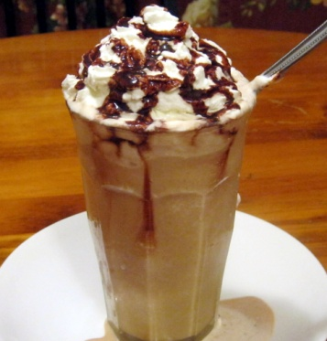
Frappés
Frappé is French and means ‘iced – of liquids’.
It is therefore a style of service where the beverage (use whatever you want or whatever the customer orders) is poured over crushed ice, or blended in a blender with ice.
The beverage used needs to be fairly flavoursome because the ice melts and dilutes the `beverage. Common options include juices and syrups.
Useful and tasty recipes can be found at:
- http://www.drinksmixer.com/cat/28/.

2.2 Prepare drink in accordance with standard recipes or to customer requests

Introduction
Drinks should be made to the house standard (recipe) or specific customer requests.

Basic requirements
The basic requirements when making cold drinks include ensuring:
- Glasses used are clean – no remains of fruit or cream and no lipstick
- Glasses are not cracked
- Glasses are unchipped
- Equipment and utensils used are clean and safe to use
- Fresh ice is used
- All food and beverage items are safe to use, that is, they have been correctly stored and handled to maintain their food safety
- Drinks are served immediately they have been made.
Please note
In the recipes which follow the quantities of ingredients have not been included as they will vary depending on:
- House recipes
- Customer requests and preferences
- Number of drinks being made
- Size of service container.

Preparing and serving milkshakes
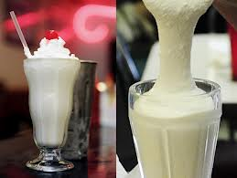
The quantities or volume of individual ingredients can vary between establishments, and even between outlets in the same venue. Some properties aim to establish a reputation for Jumbo shakes, while others might offer shakes in a variety of sizes.
Some venues may use a standard recipe (this is especially the case where the business is a franchise operation), while most businesses allow you to use your own judgement based on the fact the size of the container will limit the final amount served.
Possible method:
- Select container to be used – metal or single serve container
- Check machine and container for cleanliness
- Add chilled milk, ice cream, flavouring/syrup and malt powder (optional – as per order)
- Blend using milkshake machine. Follow house timing requirements; extra ice cream requires more time. 10 – 15 seconds is a guide
- Remove from machine and follow house procedure for service. This may be to add a lid and a straw to takeaway milkshakes, or to serve the milkshake in a glass with a straw, with the remainder of the milkshake left and served in the metal container
- Serve immediately
- Clean the machine.
Online videos
Watch the following to see how milkshakes are made:
- http://www.youtube.com/watch?v=aCG5VTCAhFw
- http://www.youtube.com/watch?v=ANOx9-1i9Sk.

Preparing and serving flavoured milk
A flavoured milk drink is milk plus flavouring.
Follow any house recipe where it exists and make sure specific customer requests are catered for (such as extra flavour/syrup) and charged for (where appropriate).
The procedure is
- Select correct size glass – check it is clean, unchipped and uncracked
- Add syrup for flavour as chosen by customer – quantity will depend on size of glass
- Top with very cold milk
- Stir with bar spoon (long-handled spoon). Ensure syrup is thoroughly mixed

- Add garnish if appropriate. Garnishes are not common for flavoured milk but may include:
- Crushed strawberries for strawberry flavoured milk
- Chocolate powder with chocolate flavoured milk
- Add drinking straw
- Place on service plate/saucer lined with a doily
- Add a parfait spoon if garnish includes fruit or other edible product.
Note: ice is optional for this drink. It is not usually added unless requested. If ice is required it should be added after milk and syrup has been stirred.

Preparing and serving smoothies
Smoothies are made using fruit and dairy products blended with ice and other natural ingredients to add flavour and colour.
You may use standard milk, skim/low fat milk, flavoured milk or soy milk.
Banana smoothie
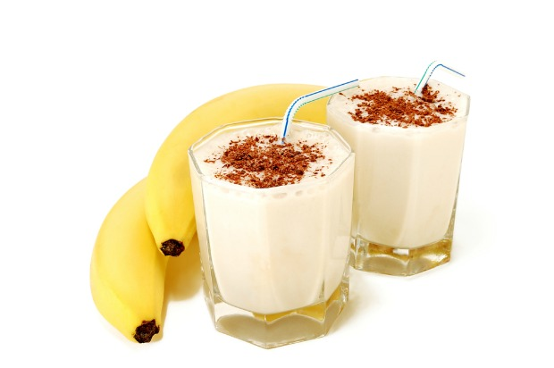
To make a banana smoothie:
- Prepare blender – check it is clean
- Prepare glass/serviceware – check they are clean
- Add ice cold milk to blender
- Add roughly chopped banana/s to blender
- Add honey
- Add yoghurt
- Add cinnamon powder (optional)
- Add ice
- Blend together until smooth
- Pour into glass – add garnish according to house recipe
- Serve immediately.

Preparing and serving hot and iced chocolate
Making hot chocolate
To make hot chocolate:
- Select mug for service of drink – check it is clean and presentable
- Add chocolate powder – most commercial hot chocolates are made using a proprietary brand of chocolate powder/hot chocolate powder as opposed to making the drink from actual chocolate (and melting the chocolate with milk in a bain marie or over low heat)
- Heat milk – milk may be heated in microwave, or by using steaming wand on espresso machine
- Add hot milk
- Stir
- Dust with chocolate powder or top with grated chocolate
- Add marshmallows
- Serve immediately.
Take time to watch the video at http://www.howdini.com/howdini-video-6677099.html for another variation.
Making iced chocolate
To make iced chocolate:
- Select glass – check for cleanliness and suitability
- Add commercial chocolate or cocoa powder or syrup
- Add sugar if required
- Add very small quantity of hot water to dissolve powder and sugar and stir
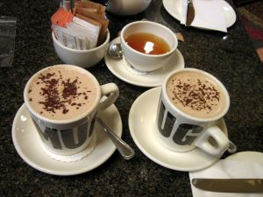
- Add ice cold milk and stir
- Top with whipped cream
- Add chocolate shavings or powder
- Serve immediately with parfait spoon.
Note:
- Ice cream is added in some venues
- This drink may be made in a blender with ice added and served as part of the blended drink.

Preparing and serving drinks with cordials
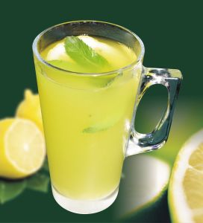
Where you need to make a drink such as lemon squash using lemonade and lemon cordial the procedure is as follows:
- Select the glass to be used – check for cleanliness
- Add ice using tongs/utensil, not fingers. Ice always goes into the glass first. Never add ice as the last ingredient
- Add the base beverage such as soda water or lemonade, according to the order placed by the customer
- Add the cordial and stir
- Add garnish
- Serve immediately. A drinking straw may be added.

Preparing and serving waters
Serving tap water
A variety of options exist for serving standard tap water.
For example:
- It may be served in a glass with ice and a slice of lemon
- It may be served with ice in a jug and the customer pours their own into a glass with ice and lemon slice
- It may be served in a refrigerated bottle/carafe to the table and each guest has a glass so they can help themselves.
Serving bottled water
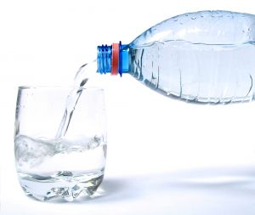
Where proprietary brands of bottled water are served the procedure is:
- Select required glass – check for cleanliness
- Enquire if customer wants ice – add ice to glass if required
- Enquire if customer would like a slice of lemon or lime – add if required
- Obtain nominated refrigerated bottle from the refrigerated unit
- Follow house policy which may be:
- Present sealed bottle and prepared glass to guest allowing them to break the seal on the bottle and pour their own drink
- Open the bottle and pour a glass of water, presenting the remainder of the bottle to guest.

Preparing and serving mocktails
A mocktail is a non-alcoholic cocktail.
The intention of offering mocktails to customers is they have a drink which appears to be an alcoholic drink but which contains no liquor.
They are served in a glass which suggests they are a ‘genuine’ cocktail, and garnished in a similar way.
The following two recipes are taken from ‘101 Mocktails: Cheers without fears’ written by Graeme Goldsworthy.
Surf Coast Sunset
METHOD: | Blend with ice and stir
GLASS: | 200ml Old Fashioned Glass
INGREDIENTS: | 60ml Apple Juice  60ml Orange Juice  ½ teaspoon Grenadine
GARNISH: | Orange slice with cherry in centre
COMMENTS: | Add the Grenadine last and watch it sink to the bottom as the setting sun.
(Source: Graeme Goldsworthy ‘101 Mocktails: Cheers without fears’, p. 82)
Pina Con Nada
METHOD: | Blend with ice and pour
GLASS: | 270ml Footed H-Ball Glass
INGREDIENTS: | 90ml Pineapple Juice  30ml Coconut Cream  15ml Sugar Syrup
GARNISH: | Wedge of pineapple and a strawberry with straws
COMMENTS: | The creamy non-alcoholic version of the famous Pina Colada.
(Source: Graeme Goldsworthy ‘101 Mocktails: Cheers without fears’, p. 115)
Online videos
See more mocktails at the following sites:
- http://www.youtube.com/watch?v=fiVV2wjBb1g
- http://www.youtube.com/watch?v=0tupptfzHDk.

Preparing and serving aerated waters and fruit juice
Preparation of cold drinks – aerated waters and juices – is straightforward:
- Select the glass to be used – check for cleanliness
- Add ice
- Add the beverage – fruit juice may need to be shaken or stirred prior to being poured
- Add garnish such as a slice of orange with orange juice
- Serve immediately – drinking straw may be added.
Preparing a lemon, lime and bitters
Many people ask for a ‘lemon, lime and bitters’ as a non-alcoholic drink.
Angostura Bitters contains alcohol. However the small amount used in this drink leads to it being considered non-alcoholic while technically it does contain a small amount of alcohol.
The process is:
- Select the right glassware – such as a highball glass
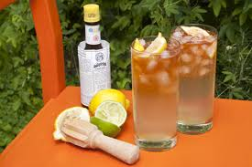
- Place up to 8 drops of Angostura Bitters and swirl glass so the bitters coats the sides of the glass
- Place ice into glass
- Fill glass with lemonade. Add slowly as the bitters will cause it to froth
- Add lime juice/cordial according to taste or house recipe
- Garnish with slice of lemon
- Place straw into glass
- Serve straight away.

Preparing and serving frappés
Frappés are beverages poured over or made with ice.
They can be made in the glass or blended in a blender.
Coffee/mocha frappé
Process is:
- Make a milk coffee using espresso – that is espresso coffee with iced milk
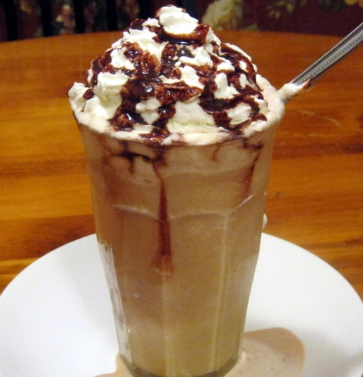
- Add sugar to taste if required: use sugar syrup
- Obtain and check glass
- Add crushed ice to glass
- Pour milk coffee over ice
- Top with whipped cream
- Drizzle coffee (or chocolate) syrup on whipped cream
- Add straw and parfait spoon.
Note: some venues use a blender to make frappes. They add the main ingredients to a blender, blend and then pour into a glass and decorate (whipped cream, shaved chocolate, syrup).
Online videos
See the following and note how to add syrup to inside of glass/drink container:
- http://video.about.com/coffeetea/Mayan-Cherry-Frappe.htm
- http://www.youtube.com/watch?v=Ylc5b3PmtSY.

2.3 Serve garnishes and accompaniments with drinks

Introduction
All drinks should be attractively presented in the appropriate crockery or glassware and using appropriate garnishes, decorations and accompaniments.
House recipes will provide guidance about the garnishes, decorations and/or accompaniments which need to be used.

Garnishing the drink
The correct garnish adds the finishing touch, and helps to provide ‘the difference’ between a drink the customer might have at home, and the one they pay for at your venue.
Typical garnishes easily used and relatively inexpensive to provide, include:
- Fruit – such as:
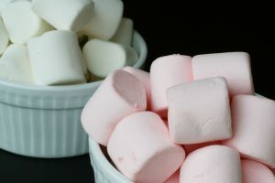
- A whole strawberry – added to side of glass
- Crushed fruit
- Full, half and quarter slices of lemon and oranges
- Wedges and knots of lime, lemon or orange
- Twist of peel
- Slice and cherry – a slice of, for example, orange with a cherry attached by a toothpick. The slice is slightly bent to give the garnish a ‘sail’ effect
- Dusting powders – chocolate, cinnamon, cocoa, nutmeg
- Marshmallows for hot chocolate
- Chocolates or mints
- Small biscuits.

Drink decorations
Garnishes are food-based as opposed to decorations which are made from paper, wood and/or plastic. Decorations are commercially prepared and cost money.
They are not food-based (they are inedible) and include:
- Paper parasols – stuck into a wedge of fruit
- Plastic animals – hung off the side of the glass: monkey, giraffe, dolphin, elephant
- Mermaids – also hung from side of glass
- Pickaxes – used to hang cherries onto side of glass.
The above are all commonly used with cocktails but have a role to play decorating non-alcoholic beverages too.
See the following site for examples of what are available:
- http://www.thepartypeople.com.au/party-supplies-cat/5582/cocktail-accessories.

Drink accompaniments
The following are examples of traditional drink accompaniments used:
- Doilies – sometimes placed under drinks to enhance presentation

- Drinking straws – usually placed into the drink but may be served in single-serve packaging.
Make sure straws are the correct size for the glass.
Flexible long straws are commonly used in tall glasses, and other alternatives include normal full-length straws, and half-straws
- Swizzle sticks – placed into a drink for the customer to stir the drink if they choose
- Coaster – placed under the drink to provide a resting place for the glass.

Serving the garnish
House recipes should guide how you use garnishes.
Garnishes may be served:
- In the drink – slices of orange and lemon can be placed directly into the drink. Make sure to use tongs to handle the fruit
- On the side of the glass – using a cut in the slice to enable the slice to be fitted to the rim of the glass
- On top of the drink – dusting powders and whipped cream are added on top of the finished beverage
- Served on the side – on a plate (perhaps with a doily/napkin), or on the saucer the glass is served on (this may be used for the service of mints. small biscuits or similar).

Points to note when garnishing and decorating drinks
Always: 
- Follow house recipes
- Use only the amount of garnish and decoration stipulated. Do not over-garnish or over-decorate
- Strive for consistency – all drinks of the same type should be garnished and decorated to look the same
- Realise garnishes and decorations cost money
- Protect garnishes and decorations from contamination.

Work Projects
It is a requirement of this Unit that you complete Work Projects as advised by your Trainer. You must submit documentation, suitable evidence or other relevant proof of completion of the project to your Trainer by the agreed date.
2.1 Demonstrate or provide other evidence you have selected the ingredients, equipment and correct crockery/glassware and/or other serviceware to:
- Prepare, garnish and serve a milkshake
- Prepare, garnish and serve a smoothie
- Prepare, garnish and serve a mocktail
- Prepare, garnish and serve a fruit juice
- Prepare, garnish and serve an aerated water
- Prepare, garnish and serve a hot chocolate or an iced chocolate.

Summary

Prepare and serve cold drinks
When preparing and serving cold drinks:
Follow house recipes
Accommodate customer requirements and requests
Use fresh ingredients
Check glassware for condition and cleanliness
If making two drinks of the same type, make them at the same time
Identify and adhere to house policies
Avoid eating the ingredients and drinking the products
Learn the whole range of non-alcoholic beverages offered by the venue on their drink lists
Serve cold drinks immediately they have been made
Garnish and decorate all drinks appropriately.

Element 3:
Use, clean and maintain equipment and machinery for non-alcoholic drinks

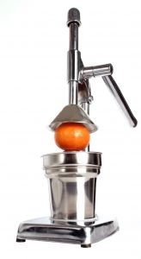
3.1 Use machinery and equipment safely in accordance with manufacturer's specifications and hygiene/safety requirements

Introduction
All equipment used in the preparing and serving of non-alcoholic beverages should be safely operated in accordance with the manufacturer’s instructions and standard hygiene and safety requirements.
The employer is responsible for ensuring the equipment is in good working order, is regularly maintained, and you are fully trained in the operation of equipment, before allowing you to operate such equipment.
You must always use equipment in accordance with the manufacturer’s instructions and the training provided.

Adhering to hygiene and safety requirements
The hygiene and safety standards and requirements in the workplace must be the basis of all your actions.
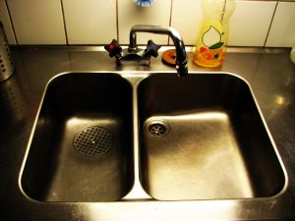
Where venue policies and procedures differ from what is provided below then you must follow the workplace requirements.
Hygiene and safety requirements may include:
- Thoroughly cleaning the equipment after each shift using the appropriate detergent and clean cloths as specified in house Food Safety Plans and/or cleaning schedules. Individual items used to produce drinks (such as blenders, milkshake machines) must be cleaned after every use
- Not wearing loose clothing around the equipment. Loose clothing can get caught on equipment and cause accident or injury
- Wearing appropriate footwear around the equipment. Shoes should be non-slip and other house requirements may also apply (such as steel-capped footwear)
- Switching the equipment on and off at the appropriate times, as opposed to leaving it running all the time
- Never removing or modifying safety guards or safety switches fitted to equipment and machinery
- Taking responsibility for personal health and safety such as being careful not to scald, burn or otherwise injure yourself.
You are under an obligation to work safely when at work.
- Trying not to spill liquid or foods on the floor and, if there is a spill, making sure it is immediately cleaned up
- Ensuring the area around the equipment is free from clutter. Clutter interferes with effective work performance and has proven to be a contributing factor in many accidents and in many spillages
- Making sure all machinery and equipment is operated in accordance with the appropriate instruction manual
- Following the requirements of any internal Food Safety Plan for the cleaning and maintenance of all items and areas in the preparation and service of beverages.

Following manufacturer instructions
You need to follow manufacturer’s instructions when using equipment because this will:
- Optimise safety
- Produce the best product
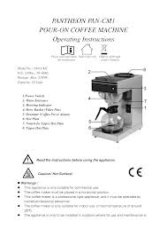
- Extend the working life of the item.
The basic items of equipment such as dripolators, coffee grinders and other smaller items of equipment will have manufacturer’s instructions accompanying them when they are purchased and delivered to the premises.
Care should be taken to preserve these and not throw them away.
It is always a good idea to read these instructions to determine how to operate items.
While these items of equipment are fairly straightforward in their operation, the instructions nearly always tell you something you did not know about issues including trouble shooting, maintenance, and/or cleaning.
More complex, larger pieces of equipment (such as individual espresso machines) are traditionally supplied with an operator’s manual (or similar) and there is sometimes free training provided to staff once the machine has been installed and commissioned.
Operator manuals are more comprehensive than basic instructions as can be seen by visiting the following site:
- http://www.lovecoffeemachines.co.uk/downloads/cma_lisa_manual.pdf
- http://www.taylor-company.com/service/resources/op_man/0060op0.pdf.

3.2 Clean and maintain machinery and equipment regularly in accordance with manufacturer's specifications and enterprise cleaning and maintenance schedules

Introduction
All machinery and equipment must be regularly cleaned in accordance with any Food Safety Program in operation at the workplace.
The equipment should also be cleaned in accordance with the manufacturer’s instructions.

Cleaning frequency
Cleaning is usually done:
- At the end of service
- Once the item is no longer required for service
- In between uses.

What is involved in cleaning?
Cleaning may include the removal of physical material – the remains of fruit juice, dairy products, dusting powder, pieces of fruit and the like – and may include:
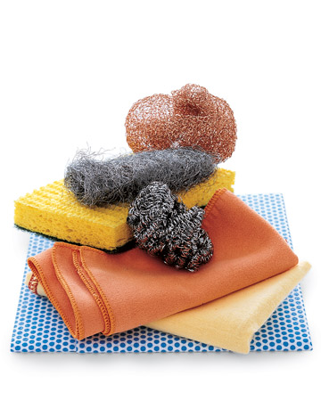
- Dismantling and cleaning relevant equipment with hot water containing an appropriate detergent and a clean cloth – checking first to ensure this cleaning method/procedure is in-keeping with manufacturer’s instructions
- Applying and rinsing off a sanitiser
- Soaking post-mix dispensers in soda water overnight – as well as wiping parts with a warm cloth to remove sticky syrup
- Washing and air drying all plunger coffee jugs, steel holders and plungers
- Cleaning down and wiping the dripolator machine and Cona jugs
- Rinsing out and/or washing teapots
- Removing and cleaning the dispensing nozzles and the gun for post-mix including cleaning the gun holder regularly, because grime and slime can build up in it too. Clean gun holder with a brush and hot soapy water.
Remember the recommended cleaning instructions for every item of equipment will be included in the printed materials supplied with the machine – the manufacturer’s instructions or the operator’s manual.
If you are unsure about how to clean a machine or item of equipment you have, then you should try the following:
- Contact the manufacturer and see if you can arrange for a copy of the recommended cleaning procedures to be sent to you – many are available via the internet
- Contact another business who has the same piece of equipment and ask if they have a copy of the cleaning instructions you can copy. It may sound strange asking your competition for help but it is often a positive experience and can establish a useful working relationship between businesses.

Cleaning espresso machines
The cleaning of the coffee machine and all associated parts must be done thoroughly and safely.
It is essential to use nominated cleaning methods as identified by management and critical to only use the cleaning products and materials designated for these tasks.
The following are representative of what applies at coffee workstations:
- Wiping down entire machine to ensure cleanliness and good appearance
- Purging reservoir of hot water, releasing steam and backwashing the machine with an appropriate cleaning solution
- Pouring boiling water to clean drainage pipes of equipment
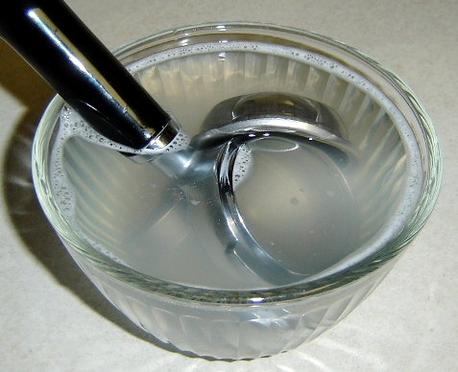
- Back flushing the machine at the end of a service cycle, using clean water to ensure no chemical or other residues are left
- Cleaning the bean hopper using wet method (see below), and drying thoroughly before refilling and storing
- Cleaning all remaining parts using dry cleaning method (see below)
- Back flushing group heads according to recommended industry methods, using a blank filter and appropriate machine detergent
- Using colour-coded cloths for cleaning such as blue for general cleaning and yellow for cleaning steam wands
- Wiping steamer wands after each use to remove milk residue
- Where there is caked-on product, wrapping steamer wands in a clean cloth, opening the valve and allowing hot water, with steam venting, to soften caked-on milk and then wiping with a damp cloth
- Washing drip trays
- Removing shower screens and diffusers if appropriate, cleaning using wet method and reassembling
- Cleaning around the inside of the group head using an appropriate brush or cloth
- Cleaning group handle and filter basket and steam arm spout after removing, using the wet method.
Wet and dry cleaning techniques
Cleaning methods for cleaning coffee utensils and equipment include:
- Wet techniques – using warm water with detergent for soaking various parts and cleaning with a sponge, cloth or scourer (for group handle only)
- Dry techniques – using a damp cloth followed by a dry cloth.
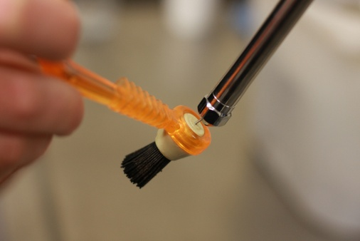
Daily and/or weekly cleaning
Steam arms
- Wipe down after foaming milk after every use
- Keep cloths in a soaking solution of mild bleach or sanitiser
- Check steam holes are clear. Use a paper clip to clear if necessary.
Blind filter – Back flushing
- Take out filter basket and clean out using scouring pad
- Fit blind filter
- Loosely fit the group handle into the group and run water. Gently jiggle it left and right to dislodge coffee grounds until water runs clear
- Lock in the filter holder and run water for five seconds – turn water off and repeat three times
This should be done at least 4 times a day and at the end of the day. Back flush more when the machine is underutilised.
Drip tray
- Remove the drip tray and wash – follow requirements of the FSP.
Panels
- Wipe down with a clean cloth soaked in warm water and detergent
- Pay attention to the areas where milk is likely to have been splashed.
Grinder
- Empty beans out of hopper at the end of the day and store in an airtight container in a dark place but not in refrigerator
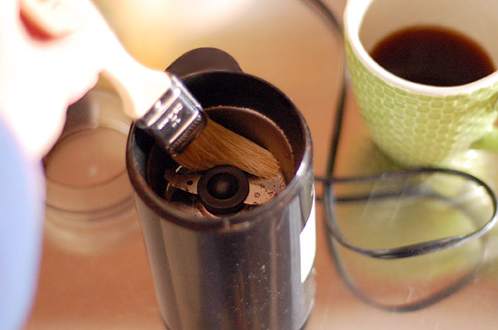
- Wash hopper at least weekly in mild detergent and very hot water – do not put through the dishwasher: dry fully
- Remove ground coffee from the dispenser and brush out with a small brush and wipe out with clean dry cloth. Removed coffee can be used for start-up the next day. Never use this coffee for customers as it is completely stale 24 hours after grinding.
- Wipe down exterior of the grinder.

Cleaning schedule
The following is a sample ‘Cleaning Schedule Checklist’.
CLEANING SCHEDULE CHECKLIST:
Month ……………………. Year ………………..
Sign each day
 | Item | M | T | W | TH | F | M | T | W | Th | F
1. | Steam Arms
2. | Blind Filter
3. | Drip trays
4. | Panels
5. | Grinder
6. | Chemical cleaning
7. | Cup tray
1. | Steam Arms
2. | Blind Filter
3. | Drip trays
4. | Panels
5. | Grinder
6. | Chemical cleaning
7. | Cup tray
1. | Steam Arms
2. | Blind Filter
3. | Drip trays
4. | Panels
5. | Grinder
6. | Chemical cleaning
7. | Cup tray
1. | Steam Arms
2. | Blind Filter
3. | Drip trays
4. | Panels
5. | Grinder
6. | Chemical cleaning
7. | Cup tray
1. | Steam Arms
2. | Blind Filter
3. | Drip trays
4. | Panels
5. | Grinder
6. | Chemical cleaning
7. | Cup tray
Checked by _____________________ Title: ________________________ Date: ____________
These are used to guide cleaning activities for the espresso machine and associated equipment.
Online videos
You can gain good information about cleaning espresso machines at:
- http://www.youtube.com/watch?v=ubtUlnntpjs
- http://www.youtube.com/watch?v=pWyuMq5Ct8Y
- http://www.youtube.com/watch?v=pefMLxN19K8
- http://www.youtube.com/watch?v=ov8yoTpnpkY.

Maintaining equipment
All equipment must be maintained on a regular basis.
This approach is known as ‘preventative maintenance’.
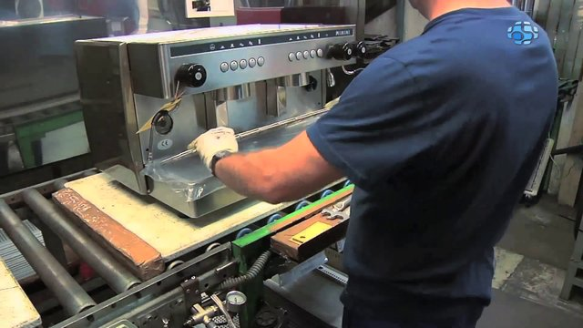
In some instances, equipment may have to be taken in to a service agent for repairs, while in other cases a service technician will visit on-site to effect necessary repairs and/or preventative maintenance.
At some stage equipment will need to be replaced or updated.
Maintenance schedules
Development of a maintenance schedule helps ensure all preventative maintenance tasks are carried out at the time required for all listed equipment.
The basis for the maintenance schedule must be a comprehensive list of all the equipment being used: everything used to produce your drinks must be listed on your equipment maintenance schedule.
Preparing an equipment maintenance schedule is the integration of all the individual service needs for all the identified items of equipment so every item is serviced and maintained as and when required.
A properly prepared equipment maintenance schedule keeps your maintenance activities on track and ensures nothing is missed.

SAMPLE MAINTENANCE SCHEDULE
For equipment used in the production of non-alcoholic beverages
NAME OF VENUE/DEPARTMENT
YEAR TO WHICH SCHEDULE APPLIES: _________
Item | Jan | Feb | Mar | April | May | June | July | Aug | Sep | Oct | Nov | Dec
Milkshake machines
Soft serve machine
Juicers
Blenders
Ice machine
Ice crusher
Coffee grinder
Espresso machine
Cool room
Under-counter refrig units
Yoghurt dispenser
Milk cooler
Backbar storage cabinet
Ice cream machine
Vertical freezer
Bench top freezer
Thick shake machine
Smoothie makers
Slushie maker
Scales
Urn

As new or different equipment is introduced into the workplace, the maintenance schedule (and the cleaning schedule in the Food Safety Program) must be updated to reflect this.
Maintenance checklists
A maintenance checklist is one (or more) lists of what has to be done when providing service to a nominated facility or item/s of equipment. The maintenance checklist guides the activities of the service technician and functions to ensure no necessary maintenance requirements are overlooked
These checklists must be developed to match the required preventative maintenance guidelines as supplied, recommended by the manufacturer or established by the organisation.
The checklist can be supplied by the manufacturer and/or generated by the establishment itself.
Where the establishment generates its own checklists it is vital they address all the areas required by the manufacturer in order to protect warranties and guarantees.
Depending on the item, maintenance checklists may be developed on a daily, ‘hours operated’, weekly, monthly or annual basis.
Maintaining a ‘second’ item
In some limited cases, establishments may elect to buy and maintain a second item of equipment. This is a ‘stand-by’ item kept ready to use whenever the unit in operation breaks down (or needs to be taken out of service for maintenance).
This situation is adopted by premises where the item of equipment:
- Is relatively inexpensive
- Is critical to the operation of the property
- Represents a significant factor in revenue-generation
- Is prone to regular breakdown.
For example, many establishments will have a ‘stand by’ blender but not a second ‘soft serve’ machine.

3.3 Identify problems promptly and report to the appropriate person

Introduction
As soon as you identify a problem when preparing and serving drinks you should report this matter to the ‘appropriate person’ so action can be taken to address the problem.


Who is the appropriate person?
This is generally:
- Your supervisor
- Duty manager
- Owner.
Check to see who the ‘appropriate person’ is where you work.
It is important issues and problems are reported immediately so appropriate remedial action can be taken or arranged as soon as possible.

A verbal report is usually sufficient but there may be a need to complete a form such as a Maintenance Request form.

What types of problems can arise?
Some problems may include:
- Customer complaints. These can be about anything: products served, other customers, comfort (noise, temperature)
- Out of date stock is being used – stock rotation needs attention
- Food not being handled, stored or processed in hygienic manner giving rise to possible food poisoning
- Poor personal hygiene practices being used by staff
- Frayed electrical cords on equipment. This is a safety issue
- Equipment not achieving or maintaining the required temperature or steam pressure
- Quality of product has dropped. This is common in situations where there are problems associated with refrigerated and/or frozen storage, or where mechanical or electrical equipment is not processing ingredients as required
- Equipment is blocked in some way due to overuse or improper regular cleaning
- Item cannot be turned on or off
- Item cannot be adjusted as required. Sometimes a piece of equipment will work but you may not be able to, for example, adjust speed, temperature or settings
- Water not flowing into the machine
- Temperature is not as required. This may include heating elements not heating up, or refrigeration units, freezers or ice cream machines (and similar) not achieving their required temperature for holding and/or processing drinks
- Part of a machine is missing
- Machine guards have loosened or fallen off
- Missing equipment – the entire item has disappeared.

What action might be taken?
Depending on the nature of the problem, the following action can be taken:

- Removing the item from use where there is a health, hygiene or food related risk
- Contacting service technicians to initiate a service call to fix the problem
- Obtaining a replacement item for use in the immediate short-term
- Acknowledging the item cannot be repaired and buying a new item.
Always apologise to customers where necessary.

Work Projects
It is a requirement of this Unit that you complete Work Projects as advised by your Trainer. You must submit documentation, suitable evidence or other relevant proof of completion of the project to your Trainer by the agreed date.
3.1 Develop a set of instructions or ‘user instructions’ suitable for use by a new staff member describing how to:
- Turn on an espresso machine
- Use an espresso machine safely to produce a shot of espresso
- Texture milk for a cappuccino
- Close down an espresso machine
- Clean an espresso machine
- Provide basic service to an espresso machine.
3.2. Provide a written report explaining what you will do if you:
- Find the hot water unit in the workplace is not providing water at the right temperature
- Determine the espresso machine is not operating correctly.

Summary

Use, clean and maintain equipment and machinery for non-alcoholic drinks
When using, cleaning and maintaining equipment and machinery for non-alcoholic drinks:
Follow manufacturer’s instructions
Adhere to house policies and procedures
Use operator’s manuals to learn about what to do
Dismantle items as required prior to cleaning
Follow cleaning schedules for cleaning all items
Provide preventative maintenance
Implement maintenance schedule requirements
Be constantly alert to identifying problems with items, equipment and machinery
Report problems immediately they are identified to the appropriate person.

Presentation of written work

1. Introduction
It is important for students to present carefully prepared written work. Written presentation in industry must be professional in appearance and accurate in content. If students develop good writing skills whilst studying, they are able to easily transfer those skills to the workplace.

2. Style

Students should write in a style that is simple and concise. Short sentences and paragraphs are easier to read and understand. It helps to write a plan and at least one draft of the written work so that the final product will be well organised. The points presented will then follow a logical sequence and be relevant. Students should frequently refer to the question asked, to keep ‘on track’. Teachers recognise and are critical of work that does not answer the question, or is ‘padded’ with irrelevant material. In summary, remember to:
- Plan ahead
- Be clear and concise
- Answer the question
- Proofread the final draft.

3. Presenting Written Work
Types of written work
Students may be asked to write:
- Short and long reports
- Essays
- Records of interviews
- Questionnaires
- Business letters
- Resumes.
Format
All written work should be presented on A4 paper, single-sided with a left-hand margin. If work is word-processed, one-and-a-half or double spacing should be used. Handwritten work must be legible and should also be well spaced to allow for ease of reading. New paragraphs should not be indented but should be separated by a space. Pages must be numbered. If headings are also to be numbered, students should use a logical and sequential system of numbering.
Cover Sheet
All written work should be submitted with a cover sheet stapled to the front that contains:
- The student’s name and student number
- The name of the class/unit
- The due date of the work
- The title of the work
- The teacher’s name
- A signed declaration that the work does not involve plagiarism.
Keeping a Copy
Students must keep a copy of the written work in case it is lost. This rarely happens but it can be disastrous if a copy has not been kept.
Inclusive language
This means language that includes every section of the population. For instance, if a student were to write ‘A nurse is responsible for the patients in her care at all times’ it would be implying that all nurses are female and would be excluding male nurses.
Examples of appropriate language are shown on the right:
Mankind | Humankind
Barman/maid | Bar attendant
Host/hostess | Host
Waiter/waitress | Waiter or waiting staff

Recommended reading
Note: all Recommended Reading is sourced from ‘Trove: National Library of Australia’ at http://trove.nla.gov.au/.
2009. Party: the complete guide to food and drinks, Penguin Books, Camberwell, Vic
2010. Mocktails: alcohol-free drinks for every occasion, Bounty Books, London
Crocker, Pat 2013, Juicing & smoothies for dummies, Wiley Canada, Mississauga, on
Doeser, Linda & Linton, Chris 2001, The Cocktail bible, Parragon, Bath
Goldsworthy, Graeme 1992, Graeme Goldsworthy's 101 mocktails: techniques, recipes and variations: cheers without fears, drinking that won't cloud your thinking, 1st ed, R & R Publishing, Epping, N.S.W
Khatau, Asha 2008, Epicure's appetisers mocktails & cocktails, Popular Prakashan, Mumbai
Reed, Ben & Lingwood, William 2009, The art of the cocktail, Pbk. ed, Ryland Peters & Small, London
Thompson, Kester & Marom, Oded 2012, Mocktails: the complete bartender's guide, Imagine, Watertown, MA
Tim Ide Masak 2011, Resep mocktail ala cafe, Gramedia Pustaka Utama, Jakarta

Trainee evaluation sheet

Prepare and serve non-alcoholic beverages
The following statements are about the competency you have just completed.
Please tick the appropriate box | Agree | Don’t Know | Do Not Agree | Does Not Apply
There was too much in this competency to cover without rushing.
Most of the competency seemed relevant to me.
The competency was at the right level for me.
I got enough help from my trainer.
The amount of activities was sufficient.
The competency allowed me to use my own initiative.
My training was well-organised.
My trainer had time to answer my questions.
I understood how I was going to be assessed.
I was given enough time to practice.
My trainer feedback was useful.
Enough equipment was available and it worked well.
The activities were too hard for me.

The best things about this unit were:

The worst things about this unit were:

The things you should change in this unit are:

Trainee self-assessment checklist
As an indicator to your Trainer/Assessor of your readiness for assessment in this unit please complete the following and hand to your Trainer/Assessor.

Prepare and serve non-alcoholic beverages
 |  | Yes | No*
Element 1: Prepare and serve a range of teas and coffees
1.1 | Select ingredients, tea/coffee making equipment and crockery/glassware to prepare tea/coffee
1.2 | Prepare drinks using appropriate method in accordance with customer requests and required timeframe
1.3 | Evaluate drink before presenting to customer
Element 2: Prepare and serve cold drinks
2.1 | Select ingredients, equipment and glassware
2.2 | Prepare drink in accordance with standard recipes or to customer requests
2.3 | Serve garnishes and accompaniments with drinks
Element 3: Use, clean and maintain equipment and machinery for non-alcoholic drinks
3.1 | Use machinery and equipment safely in accordance with manufacturer's specifications and hygiene/safety requirements
3.2 | Clean and maintain machinery and equipment regularly in accordance with manufacturer's specifications and enterprise cleaning and maintenance schedules
3.3 | Identify problems promptly and report to the appropriate person

Statement by Trainee:
I believe I am ready to be assessed on the following as indicated above:
Signed: _____________________________ | Date: ____________

Note:
For all boxes where a No* is ticked, please provide details of the extra steps or work you need to do to become ready for assessment.





